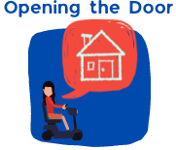
Easy read Guide to the

Opening the Door Videos
Video 1 Introduction to the Project
Watch here on Vimeo
Table of Contents
About this document 2
About the videos 3
Using times in the videos 4
Video 1 – Introduction to the project 5
Word List 9

About this document
These videos are about a project called Opening the Door.
You can read more about the project in Video 1.
3 organisations are working together on the project.
When we say ‘we’ in this document we mean the project team.
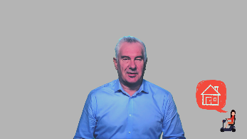 | We have written this document to help when you watch our videos.
We have written this document in easy read.
It is easier to understand.
We use pictures to help you read.
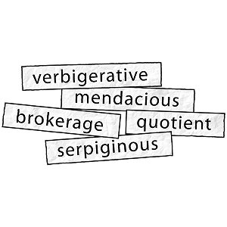 | Some hard words are in bold the first time we use them. They are darker.  We tell you what these words mean.  There is also a Word List at the back of this document.

About the videos
 | There are 10 short videos.
 | The first video is about the project.
 | The other 9 videos are about housing in Australia for people with disability.
We have a presenter for each video. A presenter is the person who does most of the talking.
These presenters are:
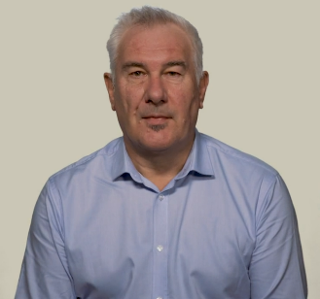 | Adrian Pisarski, National Shelter  Adrian is the Executive Officer of National Shelter.
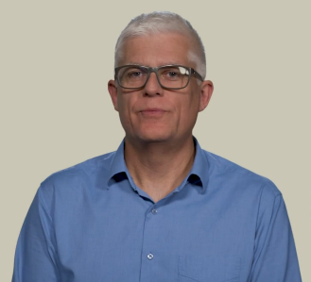 | David Havercroft, Rights & Inclusion Australia  David is the Opening the Door Project Director.
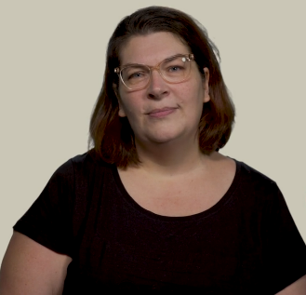 | Karen Hedley, Rights & Inclusion Australia  Karen is the Opening the Door Project Officer.

Using times in the videos
 | We have included times from the videos in this document.
You will know where you are up to here and in the video.
The times are numbers that are bold and blue.
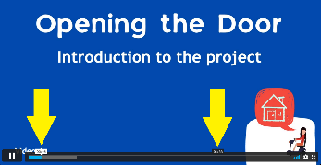 | You can find the times at the bottom when your cursor is over the time ribbon at the bottom.
 | Your cursor is what you use on your computer to point and click at things. Most people have a cursor that looks like an arrow or a hand.
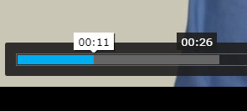 | The white time is where you have watched up to.  In this picture it is 00:11. This is 11 seconds into the video.  The black time tells you where your cursor is pointing.  In this picture it is 00:26.  If you clicked your mouse you would move ahead in the video to 00:26.

Video 1 – Introduction to the project
00:00
Video 1 is presented by David Havercroft from Rights & Inclusion Australia.
It is 2 minutes and 9 seconds long.
 | On the time at the bottom of the video it says 02:09.
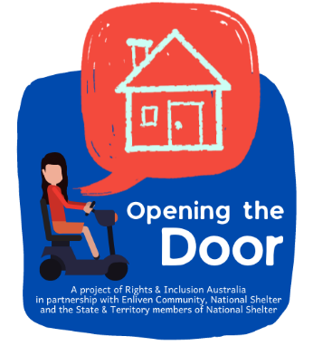 | 00:13  Our project is called Opening the Door.
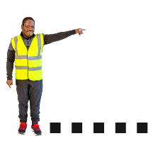 | A project is something you work on.  It has a start and an end.
3 organisations are working on the project.
They are:
 | - Rights & Inclusion Australia
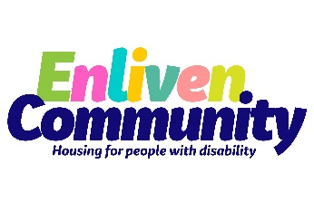 | - Enliven Community
 | - National Shelter
00:20
The project will help people with disability to identify pathways to better housing.
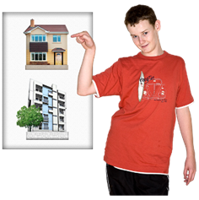 | This means we will help you find housing of your choice.  We will do this by sharing information. We will also help you learn new skills.
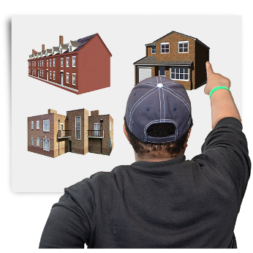 | 00:26  We will help you find real housing options for people with disability.  Options are what you can choose from.  Real options mean options that:  - They are your choice  - You have the same options as people without disability  - And they meet your disability needs.
00:32
We will do this by:
- Making online resources like a workbook.
00:37
- Forums around Australia
A forum is a meeting where you can share and talk about information.
Forums will be held face to face and online
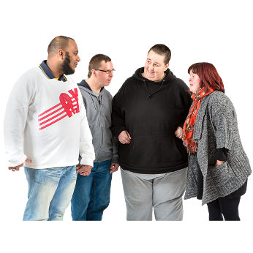 | 00:55  - Peer networks to discuss issues with others  Peer Networks are groups of people.  Everyone in the group has something the same. They help each other.  Peer Networks will be held face to face and online
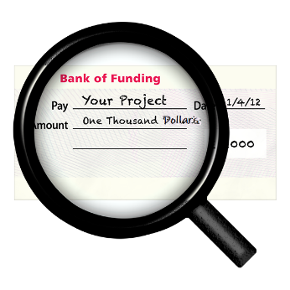 | 1:07  The Australian government have funded this project under the Information Linkages and Capacity Building program.  Funded means they have given us money to run the project.  Information Linkages and Capacity Building is also called ILC.
1:21
Our videos will help you learn about housing issues.
Anybody can watch them.
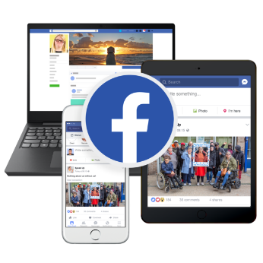 | 1:33  We will share more information about the project.  You can find this on:  - Our website  - National Shelter website  - Enliven Community website  - Facebook  - LinkedIn

Word List
Bold
Words that are darker than normal.
Cursor
Your cursor is what you use on your computer to point and click at things.
Most people have a cursor that looks like an arrow or a hand.
Forums
A forum is a meeting where you can share and talk about information.
Funded
This means they have given us money to run the project.
Identify pathways to better housing
This means we will help you find housing of your choice.
We will do this by sharing information. We will also help you learn new skills.
Information Linkages and Capacity Building
It is also called ILC. It is a government program to help share disability information around Australia.
Options
Options are what you can choose from.
Peer networks
Peer Networks are groups of people.
Everyone in the group has something the same. They share and help each other.
Presenter
A presenter is the person who does most of the talking in each video.
Project
A project is something you work on.
It has a start and an end.
Our project is called Opening the Door.
Real housing options
Real options mean options that:
- They are your choice
- You have the same options as people without disability
- And they meet your disability needs.

Images
Used under licence from Photosymbols except where noted below:
- various, used under creative commons
- Canva, used under licence
- Microsoft – Cutout People and Icons
- Funding image, p8, by Tumisu from Pixabay
More information
Contact the Opening the Door project team on
projectofficer@riaustralia.org
Or check our websites | - Rights & Inclusion Australia
 | - Enliven Community
 | - National Shelter

