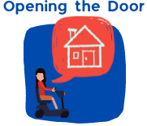
Easy read Guide to the

Opening the Door Videos
Video 2
What is Adequate Housing?
Watch here on Vimeo
Table of Contents
About this document 2
About the videos 3
Video 2 – What is adequate housing? 5
References 16
Word List 17
Slides from Video 21

About this document
These videos are about a project called Opening the Door.
You can find out more about the project in Video 1.
3 organisations are working together on the project.
When we say ‘we’ in this document we mean the project team.
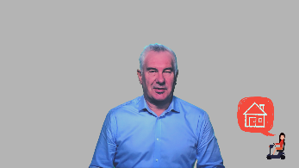 | We have written this document to help when you watch our videos.
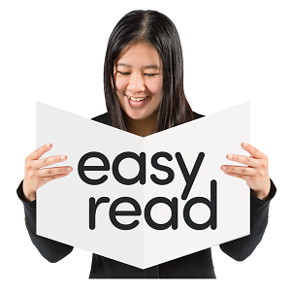 | We have written this document in easy read.  It is easier to understand.  We use pictures to help you read.
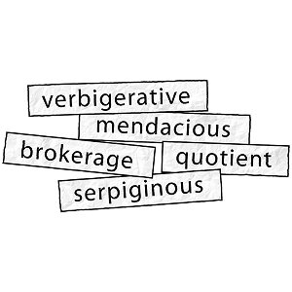 | Some hard words are in bold the first time we use them. They are darker.  We tell you what these words mean.  There is also a Word List at the back of this document.

About the videos
 | There are 10 short videos.
 | The first video is about the project.
 | The other 9 videos are about housing in Australia for people with disability.
We have a presenter for each video. A presenter is the person who does most of the talking.
These presenters are:
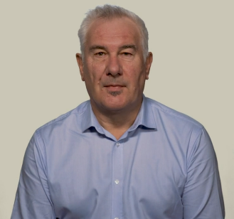 | Adrian Pisarski, National Shelter  Adrian is the Executive Officer of National Shelter.
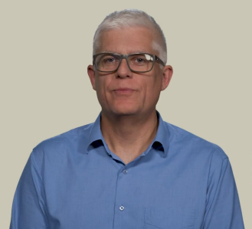 | David Havercroft, Rights & Inclusion Australia  David is the Opening the Door Project Director.
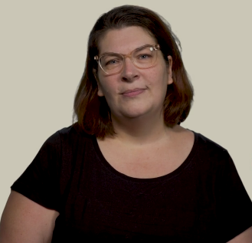 | Karen Hedley, Rights & Inclusion Australia  Karen is the Opening the Door Project Officer.

Using times in the videos
 | We have included times from the videos in this document.
You will know where you are up to here and in the video.
The times are numbers that are bold and blue.
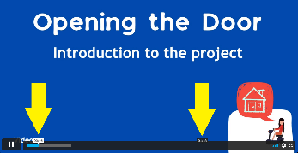 | You can find the times at the bottom when your cursor is over the time ribbon at the bottom.
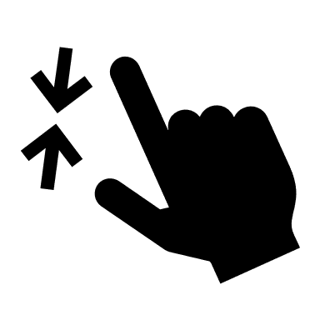 | Your cursor is what you use on your computer to point and click at things. Most people have a cursor that looks like an arrow or a hand.
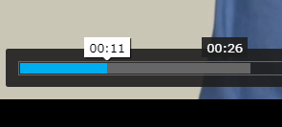 | The white time is where you have watched up to.  In this picture it is 00:11. This is 11 seconds into the video.  The black time tells you where your cursor is pointing.  In this picture it is 00:26.  If you clicked your mouse you would move ahead in the video to 00:26.

Video 2 – What is adequate housing?
Click here to skip reading the Introduction.
 | Introduction
00:00
Video 2 is presented by David Havercroft from Rights & Inclusion Australia.
It is 4 minutes and 53 seconds long.
 | On the time at the bottom of the video it says 4:53.
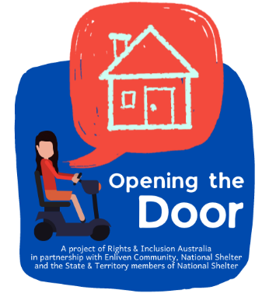 | 00:13  Our project is called Opening the Door.
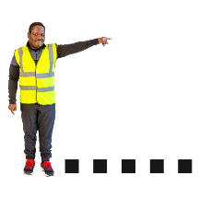 | A project is something you work on.  It has a start and an end.
3 organisations are working on the project.
They are:
 | - Rights & Inclusion Australia
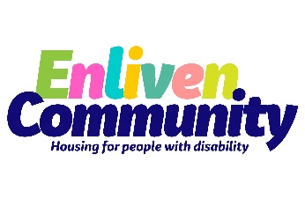 | - Enliven Community
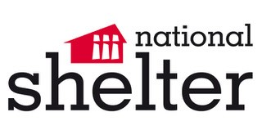 | - National Shelter
00:20
The project will help people with disability to identify pathways to better housing.
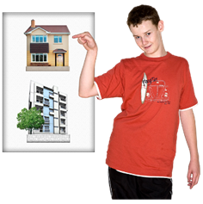 | This means we will help you find housing of your choice.  We will do this by sharing information. We will also help you learn new skills.
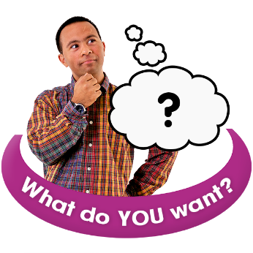  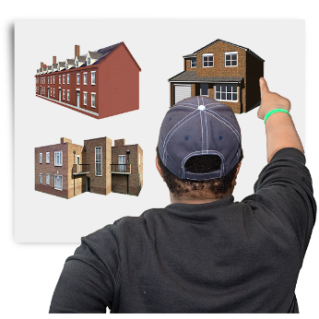 | 00:26  We will help you find real housing options for people with disability.  Options are what you can choose from.  Real options mean options that:  - They are your choice  - You have the same options as people without disability  - And they meet your disability needs.
 | What is Adequate Housing?
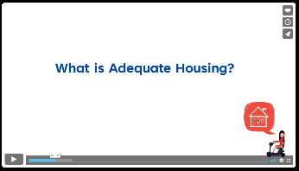 | 00:32  You have the right to adequate housing.
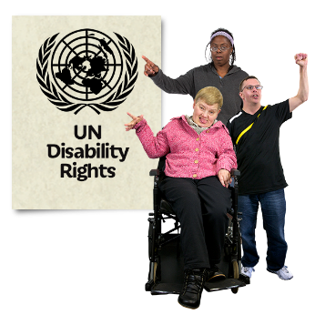 | Everybody has rights. Rights tell us what we need to have a good, safe life.  They include things like:  - adequate housing  - living where we choose  - choosing who we live with and more.
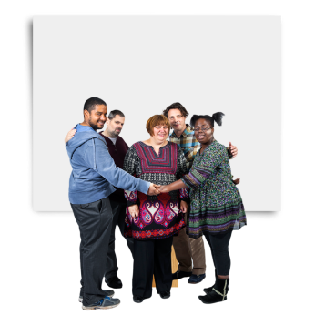 | 00:39  Adequate housing means housing that is good enough.  It is more than just a house to live in.  You must have safety, dignity & a decent home.
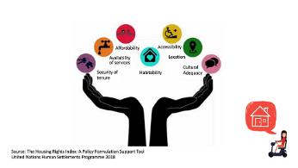 | 00:48  See a bigger slide at the end of this document..
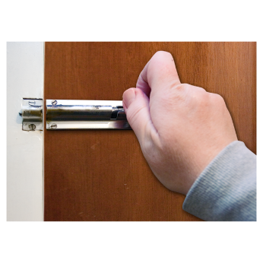 | 00:56  UN Habitat says adequate housing must:  - Be a safe place to stay  You cannot be evicted without good reason
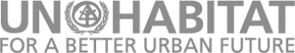 | UN Habitat is an organisation that works to improve towns and cities.
Evicted means you are asked to move out.
Some people called it being kicked out.
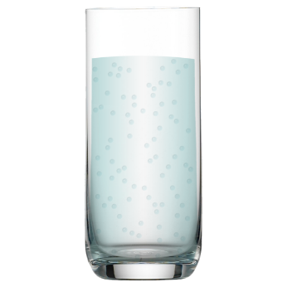 | 01:01  - Have the things to keep you safe and healthy including:  - Drinking water  - Toilet and bathroom  - Kitchen
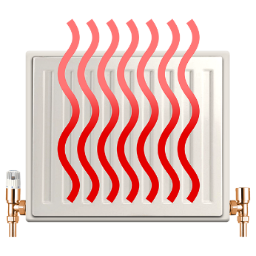 | - Heating  - Lighting  - A place to store food  - A way to get rid of rubbish
01:10
- Must be affordable
Affordable means it does not cost too much.
Find out more about affordable housing in our other videos.
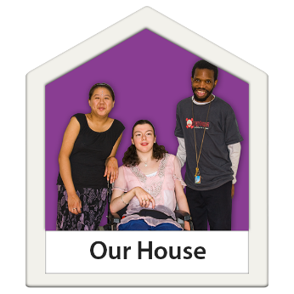 | 01:15  - Physically safe, protect from weather & hazards
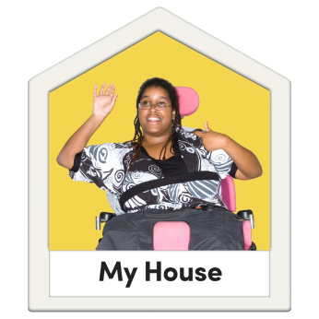 | 01:23  - Meet disability needs. This might include:  - Accessibility, like ramps and wide doorways  - Space for support workers  - A bathroom for each person living there.
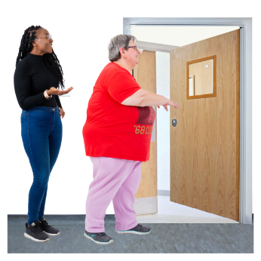 | Accessible means that everyone can use it.  There are no barriers.  Barriers are things that stop you doing something.
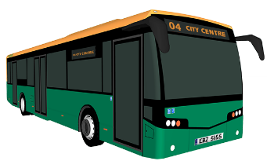 | 01:29  - With easy access to community and services including:  - Work  - Public transport  - Health services
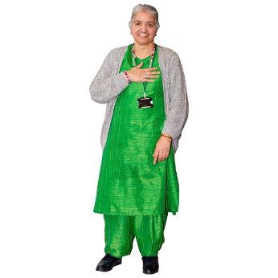 | 01:38  - Respect your culture and diversity  Culture is the way you live.  This can include the language you speak and food you eat.
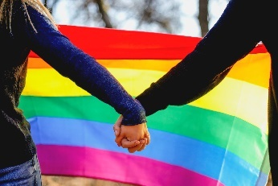 | Diversity is how we are all different.
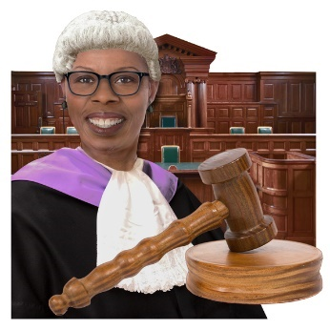 | 01:45  Your rights are recognised through laws and other guidelines.  Recognised means they are agreed to be real.  They shouldn’t be taken away from you.
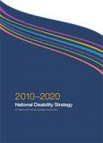 | 01:53  In Australia your rights are protected through:  - The National Disability Strategy  - Laws about accessible housing
 | Protected means that there are laws and other barriers that stop people taking your rights away.
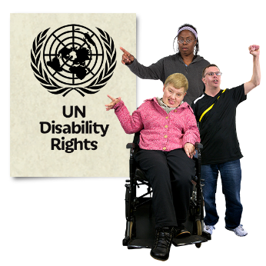 | 02:02  The United Nations have written conventions about your rights.
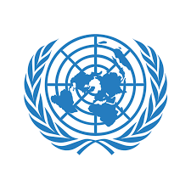 | The United Nations is an organisation. It is also called the UN.  They work across the world to protect everyone’s rights.
 | A convention is a document that explains your rights. Countries agree by the law to follow each convention.
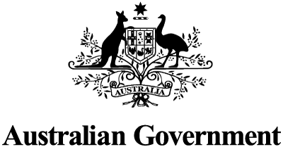 | 02:16  When Australia signs a convention we must:  - Protect those rights  - Respect the rights  - Make sure each right happens
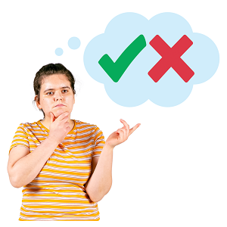 | 02:22  We all have the same rights.  This does not mean everyone has their rights:  - Protected  - Respected
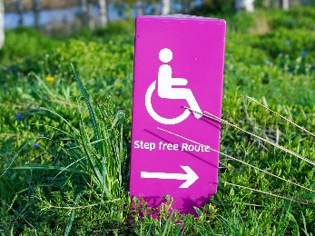 | 02:32  We all have the right to accessible housing.
 | But not everyone who needs accessible housing will find it.
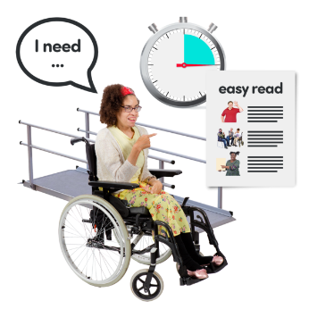 | An accessible house might have:  - Ramps  - A private backyard  - A walk-in shower.
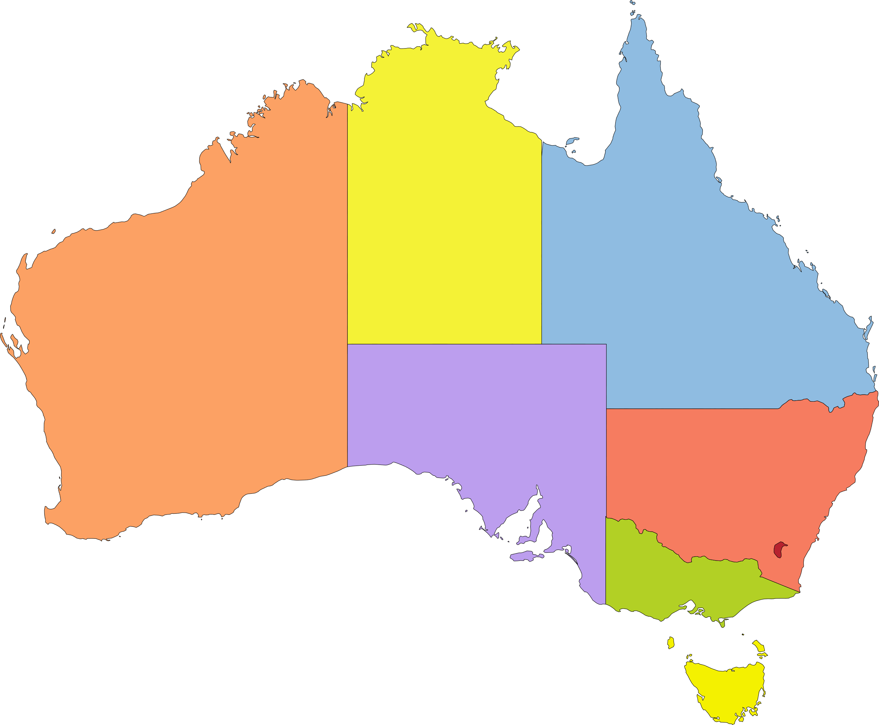 | 02:44  If Australia signs a convention:  - It must be written in law to be protected  - State and Territory governments should follow them
03:12
Australia has signed many UN conventions.
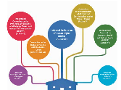 | 03:19  See a bigger slide at the end of this document.
 | In our project we mostly look at:
- The Convention on the Rights of Persons with Disabilities.
This is also called the CRPD.
Easy read CRPD is here.
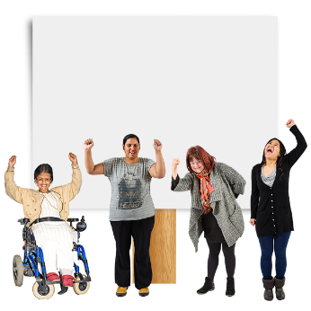 | - The Convention on the Elimination of all Forms of Discrimination against Women.  This is also called CEDAW.  Easy read CEDAW is here.
 | Elimination means to stop something completely.
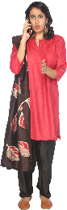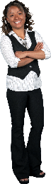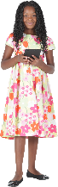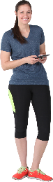 | Discrimination is when you are treated differently because of something about you.  CEDAW is about discrimination because of being a woman or girl.
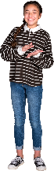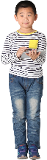 | - The Convention on the Rights of the Child  This is also called the CRC.  A child friendly CRC is here.
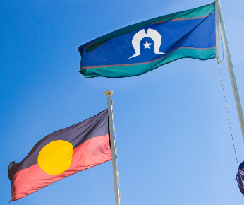 | - The Declaration on the Rights of Indigenous Peoples.  This is also called the UNDRIP.
 | Indigenous means the first people to live somewhere.
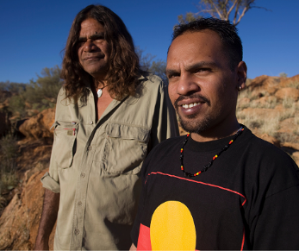 | This document tells us about the rights of First Nations people.
 | In Australia, First Nations people are also called Aboriginal and Torres Strait Islander people.
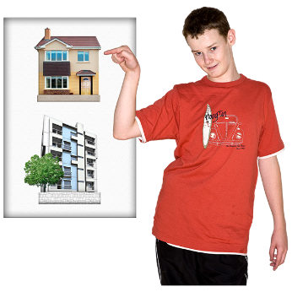 | 03:50  The CRPD talks about housing.
 | Article 9 of the CRPD talks about accessibility.
 | This includes housing.
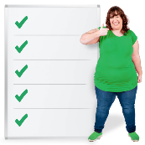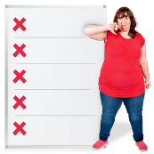 | Each subject in a convention is called an Article.  It will explain the rights and rules for that subject.
 | You have the right to have a house that is accessible for you.
04:10
Article 28 talks about living standard and social protection.
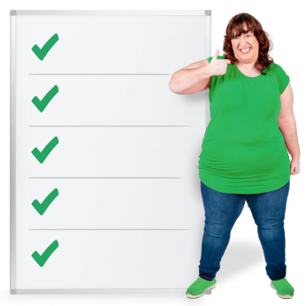 | Living standard is how well you live.  The article says you must have an adequate standard of living including housing.
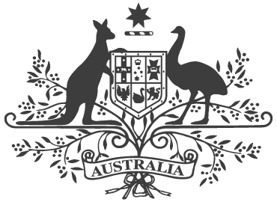 | The Australian government must help people who can not afford to be safe and well.  This is called social protection.
This includes social housing.
Public housing provided by the government is one type of social housing.
04:27
Australian laws could make sure people build accessible houses.

04:36

References
References tell you where we found our information.
United Nations Convention on the Rights of Persons with Disabilities (CRPD)​
United Nations Resources and Publications on the Right to Adequate Housing​
Universal Human Rights Instruments
Universal Declaration of Human Rights
Human Rights Explained - Fact sheet 7: Australia and Human Rights Treaties

Word List
Accessible
Accessible means that everyone can use it. There are no barriers.
Adequate housing
Adequate housing means housing that is good enough.
It is more than just a house to live in.
You must have safety, dignity & a decent home.
Affordable
Affordable means it does not cost too much.
Article
Each subject in a convention is called an Article.
It will explain the rights and rules for that subject.
Barriers
Barriers are things that stop you doing something
Bold
Words that are darker than normal.
Conventions
A convention is a document that explains your rights. Countries agree by the law to follow each convention.
CRPD
The Convention on the Rights of Persons with Disabilities is also called the CRPD.
Easy read CRPD is here.
Culture
Culture is the way you live.
This can include the language you speak and food you eat.
Cursor
Your cursor is what you use on your computer to point and click at things.
Most people have a cursor that looks like an arrow or a hand.
Discrimination
Discrimination is when you are treated differently because of something about you.
Diversity
Diversity is how we are all different.
Identify pathways to better housing
This means we will help you find housing of your choice.
We will do this by sharing information. We will also help you learn new skills.
Indigenous
Indigenous means the first people to live somewhere.
Living standard
Living standard is how well you live.
Article 28 of the CRPD says you must have an adequate standard of living including housing.
Presenter
A presenter is the person who does most of the talking in each video.
Project
A project is something you work on.
It has a start and an end.
Our project is called Opening the Door.
Protected
Protected means that there are laws and other barriers that stop people taking your rights away.
Real housing options
Real options mean options that:
- They are your choice
- You have the same options as people without disability
- And they meet your disability needs.
Recognised
Recognised means your rights are agreed to be real.
They shouldn’t be taken away from you.
References
References tell you where we found our information.
Right and Rights
Everybody has rights. Rights tell us what we need to have a good, safe life.
They include things like:
- adequate housing
- living where we choose
- choosing who we live with and more
Social Protection
The Australian government must help people who can not afford to be safe and well.
This is called social protection.
United Nations or UN
The United Nations is an organisation. It is also called the UN.
They work across the world to protect everyone’s rights.
UN Habitat
UN Habitat is an organisation that works to improve towns and cities.

Slides from Video

What should adequate housing include?
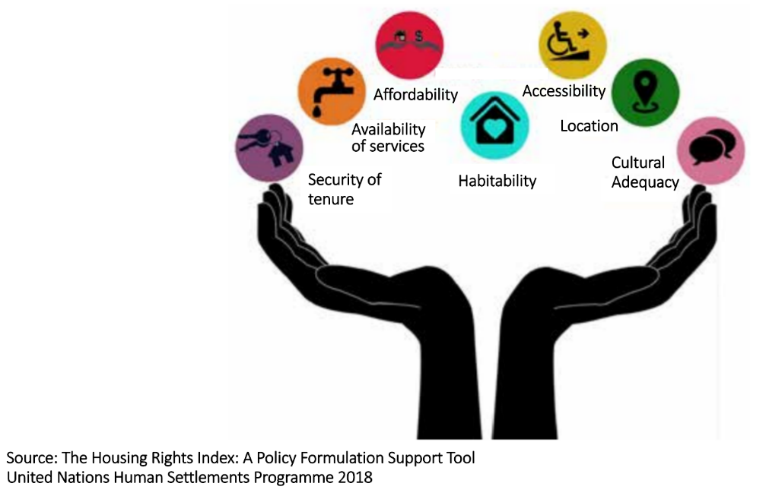

Source: The Housing Rights Index: A Policy Formulation Support Tool, United Nations Human Settlements Programme 2018
Two hands are at the bottom of the image, wrists together.
They are held palms up and fingers curved at the sides.
Between the hands are coloured balls. They are labelled:
- Security of tenure
- Availability of services
- Affordability
- Habitability
- Accessibility
- Location
- Cultural Adequacy

UN Conventions relevant to disability housing
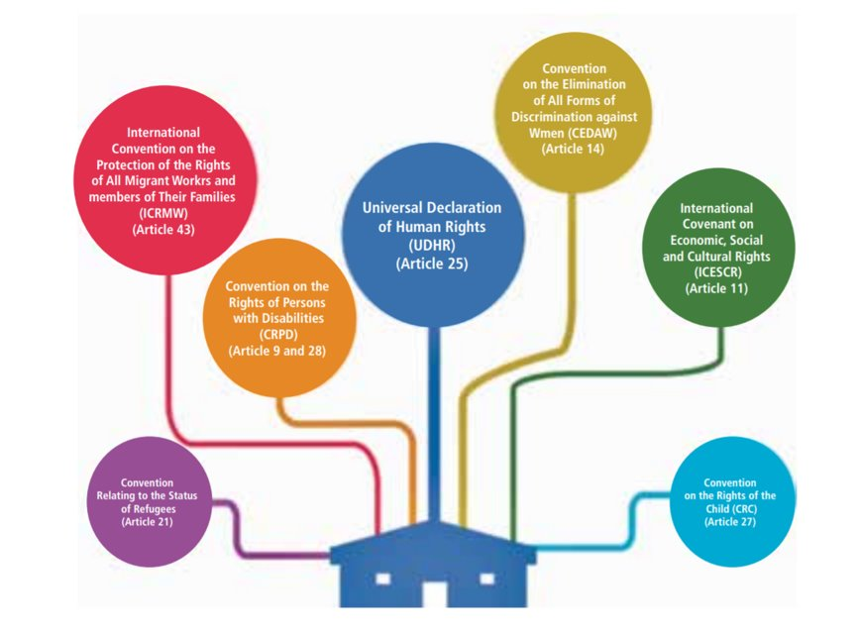
A blue house at the bottom. There is a thick blue line up to a circle saying Universal Declaration of Human Rights (UDHR) (Article 25).
There are thinner lines to different coloured circles saying, from left to right:
- Convention Relating to the Status of Refugees (Article 21)
- International Convention on the Protection of The Rights of All Migrant Workers and Members (ICRMW) (Article 43)
- Convention on the Rights of Persons with Disabilities (CRPD) (Articles 9 and 28)
- The Convention on the Elimination of all Forms of Discrimination against Women. (CEDAW) (Article 14).
- International Covenant on Economic, Social and Cultural Rights (ICESCR) (Article 11).
- The Convention on the Rights of the Child (CRC) (Article 27).

Images
Used under licence from Photosymbols except where noted below:
- various, used under creative commons
- Canva, used under licence
- Microsoft – Cutout People and Icons
- Unsplash – used under licence; photographer Yomex Owo
More information
Contact the Opening the Door project team on
projectofficer@riaustralia.org
Or check our websites | - Rights & Inclusion Australia
 | - Enliven Community
 | - National Shelter

