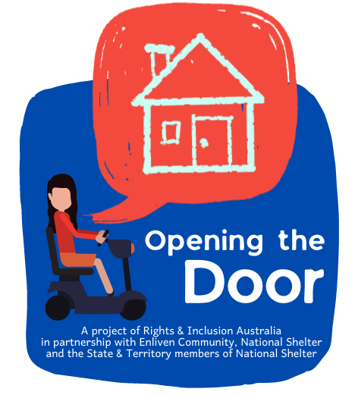
Opening the Door Project - State & Territory Forums, from July 2022
The tables below describe the content of each session.

Online Sessions:
 | Title & Description | Duration
 | Online Session 1 - Pathways to Housing for People with Disability in your state or territory  A panel presentation and discussion on opportunities & challenges of buying and renting housing in your state or territory.  We will discuss the private housing market, and public, social and affordable housing.  Presenters to include representatives from:  - Public Housing Authority  - Community Housing Sector  - Private Housing Industry  - Finance Sector | 1.0 - 1.5hrs
 | Online Session 2 - Dealing with Tenancy Issues for People with Disability in your state or territory  A panel presentation and discussion on your rights as a tenant in your state or territory.  We will discuss tenancy issues for those in the private housing rental market, and public, social and affordable housing, as well as supported independent living houses. This includes how you can get assistance.  Presenters to include representatives from:  - Community legal services  - Consumer Affairs  - Community Housing Sector | 1.0 - 1.5hrs

Online Sessions (continued)
 | Title & Description | Duration
 | Online Session 3 - National Disability Insurance Scheme – Home & Living supports  A presentation and discussion on accessing NDIS home and living supports  We will discuss:  - How the National Disability Insurance Scheme (NDIS) can assist you with Home & Living supports - from funding of specialist disability accommodation, to assistance with ‘individualised living options’  - How to apply for Home & Living supports  - Making complaints regarding housing and support provision  - Pending changes to the NDIS | 1.0 - 1.5hrs

Face-to-Face Workshop Sessions:
 | Title & Description | Duration
 | My Housing Matters Workshop  At this four-hour face-to-face workshop, we will:  - Recap presentations and discussions from the three Online Sessions:  - Pathways to Housing for People with Disability in your state or territory  - Dealing with Tenancy Issues for People with Disability in your state or territory  - National Disability Insurance Scheme – Home & Living supports  - Discuss current housing issues that you are facing  - Discuss opportunities to achieve choice and control with your housing options.  Lunch will be provided  Please note that this session is solely for people with disability, their families/ friends/ unpaid, carers and any support needed to attend. | 4hrs, including lunch

