Opening the Door project
Project Information Sheet

What is the Opening the Door project about?
The Opening the Door project is run by Rights & Inclusion Australia (R&IA) and aims to support people with disability to achieve choice and control with their housing options. The project is for all people with disability regardless of their type of disability or age, and whether they are a participant in the NDIS or not.

Our Focus
The Opening the Door activities are based on the following four principles, each centred around the individual, guiding good housing outcomes for people with disability:
Rights: You have the same rights and responsibilities regarding your home as others.
Choice: You have a place you call home.
Inclusion: You are able to participate both socially and economically in mainstream society.
Control: The provision and management of housing is separate from the provision and management of paid support.
From these four principles, the Opening the Door project is focused on the following areas to help you on your housing journey:
- Living Arrangements - Clear Vision and Strong Ideas:
  - How do I decide? Who helps me to decide?
  - Identification of where, how and with whom to live
- My Home - Housing Options
  - Identification of suitable affordable housing options and supports
  - Funding & financing – Government, NDIA and other opportunities
  - Goals & planning – decision making & risks
- Problem solving and finding help
  - Tenure & tenancy rights
  - Advocacy
  - Other assistance to help

Opening the Door project activities

Online Forums
From 2021 to 2023, R&IA hosted a number of forums in every state and territory in Australia. These were made up of a series of online presentations with questions and answers, followed up by workshops. We also hosted several online Lunchtime Forums on particular topics, as well as a yarning circle with First Nations people in Central West NSW.
We are continuing to deliver information through online Lunchtime forums - or ‘Lunchtime Conversations’ as we call them. You can view the video and PowerPoint of our recent Home Modifications forum on our website here. We will provide details of upcoming forums on our website.
‘Let’s talk Opening Doors’ engagement platform
The Opening the Door project is developing an online community engagement platform which will allow people to engage on housing issues. This will include moderated community discussion boards where people can discuss issues and ask questions that are relevant to them. The Opening the Door project team has good connections with housing experts, who can provide answers for those questions we cannot answer ourselves. The engagement platform will be launched in November 2023.
Peer Networks
We want to engage with peer networks across Australia to discuss housing options, and to assist peer network members to source information that can help them with their housing choices. We want peer networks to be actively involved in the opportunities that the Opening the Door project provides for making housing choices a reality.

Want to know more?
To find out more about the Opening the Door project, contact Rights & Inclusion Australia at projectofficer@riaustalia.org.au.
Project Partners
The Opening the Door project is funded through the Australian Government’s ‘Individual Capacity Building’ grant program, overseen by the Department of Social Services. The project is being delivered in partnership with National Shelter, the state & territory members of National Shelter, and Enliven Community.
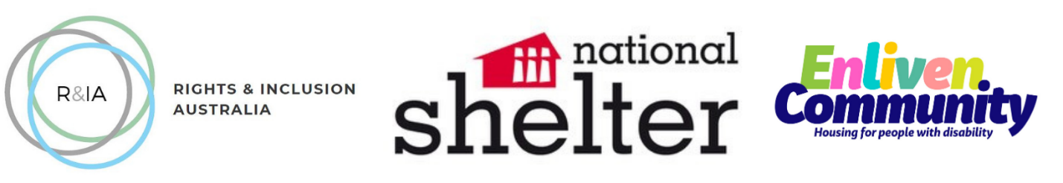

Queenslanders with Disability Network (2018). My Housing Matters: Housing matters for people with disability Workbook

