Rights & Inclusion Australia Inc.

Submission: Integrity of National Disability Insurance Scheme (NDIS)
April 2026

Version: 1.5

Enquiries:
email contact@riaustralia.org
phone +61 417 402 030
post PO Box 88 Pacific Palms NSW 2428

27 April 2026

Joint Standing Committee on the
National Disability Insurance Scheme
PO Box 6100
Parliament House
Canberra ACT 2600

Inquiry into the Integrity of the National Disability Insurance Scheme

Thank you for the opportunity to lodge a submission into the Integrity of the NDIS.
Rights & Inclusion Australia Inc (R&IA) members and directors have extensive involvement in addressing housing inequity, including the UN Convention on the rights of persons with disabilities (CRPD) ratified by Australia in 2008, development and implementation of Standards Australia accessibility standards, and Australian Building Codes Board (ABCB) Liveable Housing NCC requirements.
R&IA members have lived experience in a range of housing hands-on and community projects.
R&IA with Australian Network For Universal Housing Design (ANUHD) were actively involved in negotiating and adoption of the Livable Housing mandatory requirements in all Australian states and territories except NSW and WA.
Any questions or clarifications should be addressed to R&IA director Michael Fox at 0417 402 030 or contact@riaustralia.org.

Michael Fox AM Allan Hunter
R&IA director R&IA director

Recommendations
Recommendation 1.- A public enquiry. into the entire SDA new build program including operation of the ‘market’, associated stewardship and regulations and whether ‘choice and control’ and ‘value for money’ have been achieved. 11
Recommendation 2.- Certification, Access Institute and SDA assessors. procedures review including certification, qualifications and relevant experience regarding the SDA Design Standard. 11
Recommendation 3.- Independent regulator ABCB to be appointed to carry out a transparent and accountable review of the SDA process, including terminology and harmonising with Australian Standards and the NCC. 11
Recommendation 4.- ACCC review of all key SDA aspects including pricing framework, comparisons against actual and market costs, value appropriateness, profit margins, market operation and governance. 13
Recommendation 5.- Review existing SDA Design Standard. review all requirements including relevance, cost, value for money and application in a range of situations with a diverse range of clients 14
Recommendation 6.- SDA fire protections sprinklers. Issues regarding SDA fire protection sprinklers to be referred to ACCC or ABCB including misleading statistics, actual costs, existing NCC provisions and classes of buildings. 15
Recommendation 7.- Adopt existing standards. Cheaper and quicker to use existing standards such as ABCB liveable housing. Wider issues including NDIS failing to mention wiring rules (even if it is a little out of date) and International strategies adoption the internationally recognised 6601 series of standards and relevance to backup power supply design considerations. 18

Contents
Recommendations 1
Contents 2
Introduction and overview 3
Rights & Inclusion Australia 3
Enquiry Focus 3
Overview 4
SDA - a brief background and submission context 5
The SDA vision 5
2026 SDA State of play 6
2019 SDA reboot 8
SDA Issues and recommendations 11
Loss of a range of alternatives 11
SDA cost blowout 13
SDA Class 1a family homes 14
SDA Alliance campaign for sprinklers 15
NCC classification - inability to self evacuate 16
Who’s in charge of decision-making? 17
Failure to adopt NCC 2022 Liveable Housing requirements 19
Backup power and Renewable energy 20
Renewable energy 20
Backup power 21
Backup changeover times 22
Unqualified self appointed experts 23
Conclusions 25

Introduction and overview

Rights & Inclusion Australia
R&IA members and directors provide extensive experience and involvement in the development and implementation of accessibility legislation and provisions in Australia and internationally through the CRPD (UN Convention on the rights of persons with disabilities) ratified by Australia in 2008.
R&IA director Michael Fox is an architect, planner and access consultant, refer www.accessaustralia.com.au and relevant experience includes
- Initial Standards Australia ME64 / AS1428 Chair – 1980s and 1990s
- President of RI Global during CRPD drafting and adoption – 2004 to 2008
- Accessible housing programs 2010 to 2020 with ANUHD
- Member of ABCB NCC livable housing committee – 2022
R&IA director Allan Hunter had a career as an electrical engineer on a range of defence projects including the Collins Class submarine, Joint Operational Radar Network (JORN) and Barra Sonobouy in roles including. Roles and responsibilities included support, reliability, systems, and safety engineering aspects.
Since 2021 Allan has been advocating for NDIA to address SDA structural problems and upgrade the SDA new build program to incorporate project management practices commensurate with a multibillion-dollar infrastructure build program. Allan is also involved researching and developing best practice backup power supply in disability housing and working with a range of organisations including Australian Rehabilitation Assistive Technology (ARATA) and Adelaide University.

Enquiry Focus
“The Joint Standing Committee on the National Disability Insurance Scheme will inquire into and report on:
- the nature and extent of non-compliance, including fraud and sharp practices, in the National Disability Insurance Scheme;
- the impacts of non-compliance on NDIS participants and their families;
- the effectiveness and adequacy of successive government policies to improve scheme integrity, safeguard participants, and tackle non-compliance; and
- any legislative or other reforms required to strengthen scheme integrity
And defines “sharp practices “ as
“a range of practices involving unfair treatment or taking advantage of people, including over-servicing, high pressure sales and inducements... While the sharp practices may not necessarily be unlawful, they are considered unethical, dishonest and not in the interests of the person with disability. “
While acknowledging that the Committee encourages “submissions which comment on the conduct of providers or others in general terms” and noting the additional considerations that are applied to specific examples - the close relationships between NDIA and a range of advocacy organisations including Summer Foundation (and associated entities), Access Institute, a CAA, Master Builders Association (MBA ) and others advocacy organisations needs to be explicitly identified and discussed.

Overview
This submission concentrates on a range of “sharp practices “ as defined by the Committee associated with the Specialist Disability Accommodation in the NDIA framework.
As well as a brief background and context including the original goals and objectives of the SDA new build program work, the submission identifies a broad range of issues and associated recommendations .
Examples of inappropriate and unethical conduct are highlighted using SDA requirements for backup power and renewable energy
As well as the conclusions, a series of recommendations are detailed on both the summary at the front of this submission and immediately following explanatory text.

SDA - a brief background and submission context

The SDA vision
Although couched in market terms, the SDA approach originally proposed provided for some very specific government backed intervention to achieve specific housing policy objectives. Here are three quotations to illustrate the “vision” for SDA.
The Summer Foundation 2016 position statement included the following aims:
- “Housing is accessible and its location helps to build community connections.
- Housing choices are diverse, including enabling people with disability to live with their family.
- Investors have faith in the structure and delivery of the NDIA’s housing payment scheme.
- The design and delivery of housing and support models is innovative and highly collaborative.”
Also in 2016, the following recommendations from the Commonwealth Joint Standing
Recommendation 3
3.66 The committee recommends the Commonwealth government explore all possible proposals for disability accommodation, and the ways it can assist in bringing them to fruition.
Recommendation 4
3.67 As part of the analysis of proposals, the committee recommends the Commonwealth should assess how financially accessible they are for people with disability and their families.
Recommendation 6
3.102 The committee recommends the Commonwealth government explore capital sharing, securitisation, and joint ownership options to expand the provision of appropriate accommodation for people with disability.”
From 2017:
“The vision for SDA as described by the NDIA is a vibrant, multifaceted, open and competitive marketplace operating sustainably to meet the housing demands of NDIS participants with very high needs who require a specialist solution”
and
“"A large variety of financing options (both debt and equity) and financing terms, including banks, institutional investors, high net worth individuals, families of tenants, developers and other innovative forms of financing (e.g. social infrastructure bonds) underpinned by a good understanding of the vacancy risk"
The 2018 SDA Pricing and Payments Framework Review expectation was that, in the medium term, the SDA market would be characterised by: “new types of market entrants aside from early movers and traditional accommodation providers” and “greater choice and emergence of different or innovative housing models for scheme participants”
However in 2019 AHURI report acknowledges that:
“The philosophy underpinning the NDIS and SDA is one of choice and control for people with disability themselves. This research clearly indicates that in relation to SDA, access to both of these is critically compromised”.

2026 SDA State of play
The result, at the end of 2025 is some great SDA homes which are literally life changing in a lot of cases. Brand-new fully accessible homes complete with (effectively) lifetime capped at 25% + Commonwealth rent assistance (CRA) come with an NDIS plan providing funding for a range of support worker activities contributing to what in some cases, is first time living independently in their own rental property. Particularly if it’s been tailored to meet their specific needs.
However there are problems. Figure 1 shows the change in narrative from the start of the SDA program in 2016 with around 17,000 NDIS participants in SDA. An overview is a Four Corners episode with the more detail here.
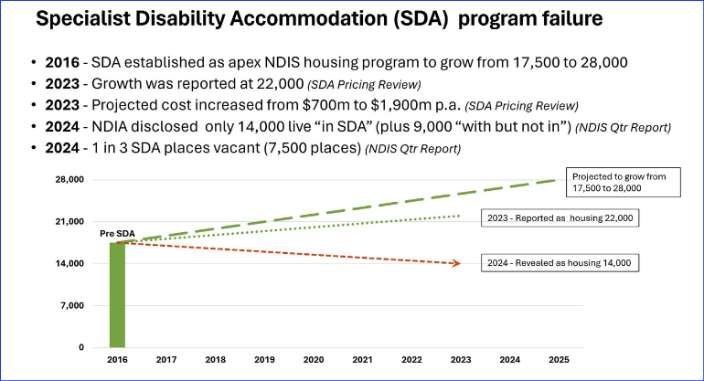
Figure 1 - SDA changing expectations or incipient program failure?
Figure 2 showing the persistent unmet demand over the last 3 years unchanged of around 38%. Over the same timeframe, spending on SDA have almost doubled.

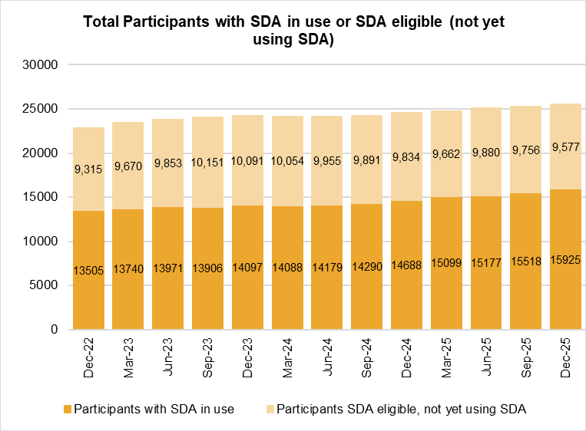
Figure 2 - stubborn unmet demand
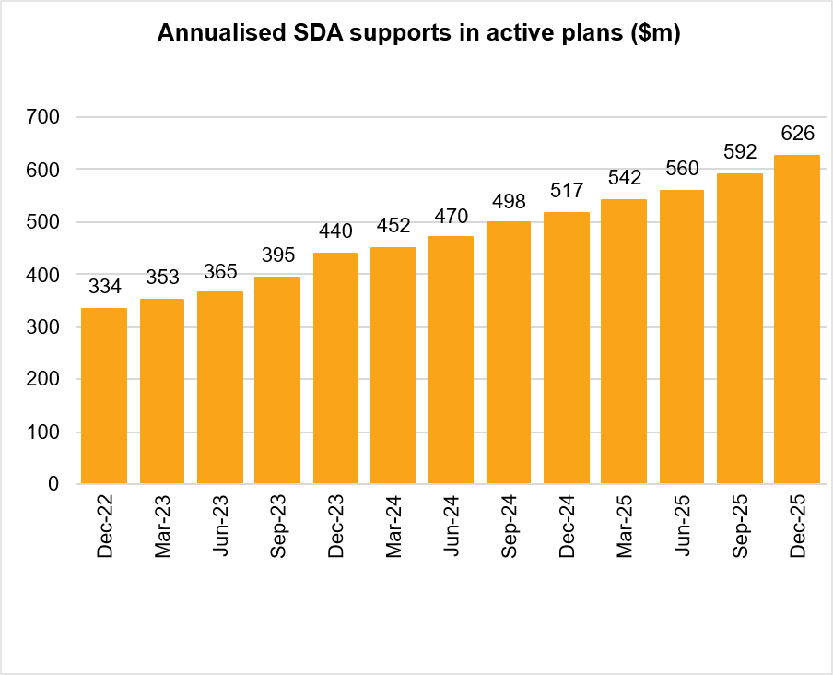
Figure 3 - while SDA costs almost double

What charts don’t show is the complex nature of a generic “SDA” hiding the complex mixture of legacy group homes, new build apartments, and three-bedroom mini group homes illustrated in Figure 4.
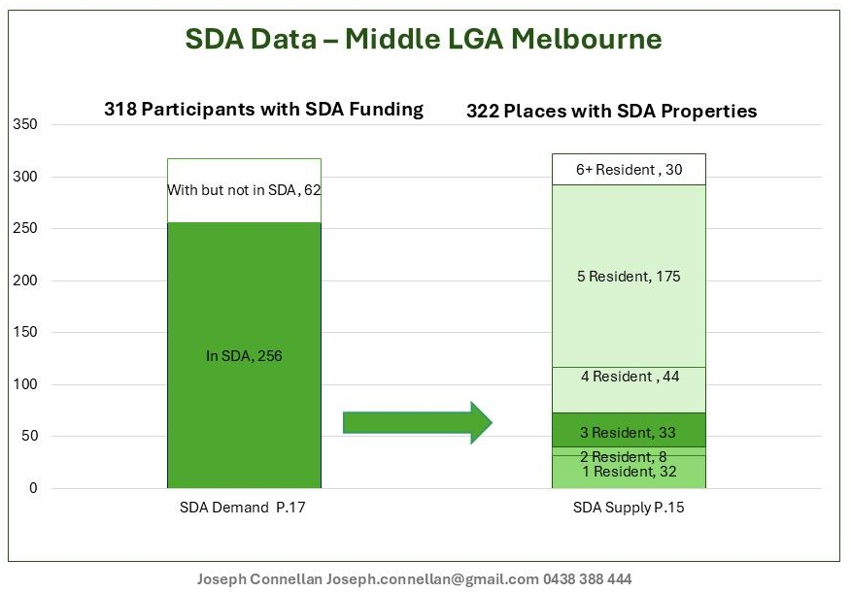
Figure 4 - SDA detail
That’s before you consider is a mixture of oversupply and undersupply depending on which city, suburb, or country area under consideration, or bridge the disconnect between a diverse range of disabilities eligible for SDA but not considered during the SDA design program.
What’s developed is a risk averse market dominated by a handful of investment funds where a standardised mandatory template is repeated at scale, stifling innovation and relying on vacancy rates to provide market signals due to the centrally planned costing mechanism.
This R&IA submission looks at the problems this causes along with the effect on NDIS participants and suggest various means of addressing or bypassing the problem.
Which brings us back to the 2019 reboot of the SDA new build program.

2019 SDA reboot
In November 2018, NDIA outsourced design and control of key elements to building industry interests associated with the Livable Housing Australia board via contract M000000541.
Using the original 2011 Livable Housing Australia campaign to encourage accessible homes as inspiration (a miserable failure; never achieving more than 5% of the target number of accessible homes), the 2019 relined approach ignored a range of Australian and international leading-edge examples of universal design practice - including the NZ Lifemark program - and used Trumpian logic to justify basing the updated 2019 SDA Design Standard on the previously failed LHA program:
"With LHA being the standard bearer for accessible design standard is in Australia, LHA has experience in implementing design guidelines and developing and managing registered assessor networks"
The result was the Robodebt inspired statement of breathtaking inadequacy in addressing NDIS legislative requirements:
""The SDA Design Standard will be a standalone design guideline document for SDA which draws on:
• The Silver and Platinum level requirements of the LHDG,
• Australian Standard AS1428.1 suite of standards (Design for access and mobility for new buildings) and
• AS2890.6 (Parking facilities for people with disabilities)"
What is missing (and the reason for the Robodebt reference) is addressing the NDIS legislative requirements of "reasonable and necessary" and "value for money", or the needs of the 6% most severely disabled NDIS participants with complex housing needs.
Instead of addressing a diverse range of physical as well as cognitive, neurological, and sensory issues- which was the point of the exercise - the approach was to use a couple of Australian Standards already familiar to the developers:
Where the resident profile and/or requirements are unknown at the time of design, utilising AS1428.1 future proofs design for general use by different users.
Other benefits of referencing AS1428.1 include:
There is already a good market supply for products and fixtures that comply with AS1428.1. For example, bathroom and door hardware suppliers have selections of products that are designed for wheelchair users.
AS1428.1 is well known and accepted in the industry by Disability Access Consultants, Architects and Building Certifiers. Of the 35 LHA IRG members (listed in Appendix 2) who were provided with the SDA Design Standards Draft 1 for feedback, overwhelmingly supported use of the AS1428.1
If the Standard was not included, costs to the project would be much greater because:
• The scale of review of the details to understand what is different if anything for each assessment would be another project in of itself.
• An extra layer of training would add time and cost potentially limiting the number of professionals who may be capable of undertaking SDA assessments when professionals already have in-depth knowledge of AS1428.1."
In other words, the extensive use of as 1428.1 is not because it addresses the “needs, wants, and requirements” of a diverse range of severely disabled potential residents in SDA; it’s a convenient Standard which can be adopted because it suits the skill sets of access consultants and building industry interests.
This leaves a fatally flawed SDA Design Standard where there is no evidence based link or connection between the requirements of someone with a severe disability, and the corresponding requirements in the SDA Design standard.
This leaves no provision within the SDA new build program for appropriate assistive technology that meets the specific needs of an NDIS participant with a severe disability. That money has to come from somewhere else in the budget and is currently not accounted for nor the responsibility of the SDA assessor.
It defies belief that no one in the NDIA or NDIS commission is actually responsible for making sure that an SDA resident with a severe disability is safe in that SDA registered home, or that the appropriate assistive technology has been made available.
This leaves the door open for favoured consultants, well-connected and influential lobby groups, and anyone else that may be interested in imposing requirements they are “good ideas”
The proposal to make fire protection sprinklers mandatory in SDA by the SDA Alliance is one example. The proposal by the HIA to create a new NCC classification just for SDA and consultation directly the ABCB is another.

SDA Issues and recommendations

Loss of a range of alternatives
A 2015 AHURI report highlights the importance of safety and security as well as a range of different types of homes:
“Participants who moved to social housing experienced more secure and affordable tenancies, and most hoped to be able to remain in their new homes permanently. Participants who moved to their own homes (including shared equity arrangements) experienced pride and a sense of security. Participants who moved to private rental, in contrast, experienced less secure housing, as well as significant affordability stress”.
The original intent was for SDA to comprise
“"A large variety of financing options (both debt and equity) and financing terms, including banks, institutional investors, high net worth individuals, families of tenants, developers and other innovative forms of financing (e.g. social infrastructure bonds) underpinned by a good understanding of the vacancy risk"
Unfortunately, the SDA has largely failed to produce on both counts. The new build program is dominated by commercial wheelchair accessible rental properties built to a single “one size fits all” in line with an SDA Design Standard template replicated at scale.
Current policy (apart from NSW and WA) is to adopt mandatory ABCB Liveable home requirements in all mainstream housing:
Accessible and well-designed housing supports independence and social and economic participation. Increasing the availability of accessible housing provides choices on where to live an, who to live with, and enables people with disability to visit, socialise and connect with neighbours, family, and friends. Improved take up of universal design principles will support people regardless of age or disability to live in their home through all stages of their lives.
The NDIS legislation made provision for a range of SDA registered property types from NCC Class 1a family home right through to institutional style NCC Class 3. For some SDA eligible engaged participants, minor modifications to a LHA “beyond Voluntary” standard home would provide a cheaper alternative suitable for both community housing providers and a range of residents including owner occupiers.
This would provide some redress for the current situation where there are just under 15,000 NDIS participants in a rental accommodation, and only 16 owner occupiers.
Similarly the control and management of the majority of SDA properties outside of the legacy group homes is dominated by 4 or 5 large investment funds exclusively investing in NDIS SDA properties. For example:
Synergis Fund is aiming to make an additional $1bn of investment over the next five years.
We are an investment fund providing investors a doorway to an emerging social infrastructure asset class.
We target positive social impact and attractive long-term, risk-adjusted financial returns supported by Commonwealth Government rental payments.
And backed by building industry interests such as the Property Council of Australia with well-organised media support including the Australian Financial Review and (for example) online Property Investor.
The advocacy side is dominated by a handful of well-connected organisations and individuals including, Housing Hub CEO Alecia Rathbone, SDA developer Brent Woolgar, and SDA Alliance CEO Jeremy Hope all quoted in the March 2024 Property Investor article
Recommendation - A public enquiry. into the entire SDA new build program including operation of the ‘market’, associated stewardship and regulations and whether ‘choice and control’ and ‘value for money’ have been achieved.
Recommendation - Certification, Access Institute and SDA assessors. procedures review including certification, qualifications and relevant experience regarding the SDA Design Standard.
Recommendation - Independent regulator ABCB to be appointed to carry out a transparent and accountable review of the SDA process, including terminology and harmonising with Australian Standards and the NCC.

SDA cost blowout
Promises of cost-effective and widely available housing courtesy of “impact investment” simply haven’t been met. A large part of it is due to a pricing framework which not only fails to include “reasonable and necessary” and “value for money” criteria, but it also doesn’t even budget for or identify of costs and additional of the diverse range of NDIS participants with severe disabilities.
In 2017, the Australian Financial Review (AFR) highlighted the minimal cost of modifications for a SDA registered one-bedroom apartment.
“the specialist disability modifications (costing between $4000 and $12,000) need on each apartments - such as higher benchtops or the ceiling hoist Miss McIntosh needs to get out of bed”
Fast forward to the 2022-23 benchmark construction costs, and the additional costs of upgrading a basic apart one-bedroom apartment to SDA High physical support is around $148,000.
The initial goal of around 28,000 NDIS participants - around 6% most disadvantaged - a cost of around $700,000 dollars per year. 10 years later we’ve only achieved just around 15,500 NDIS participants under SDA roofs – at a cost of $481m annually.
Freed from the need to include “reasonable and necessary” and value for money” considerations, reasons for the cost blowout include:
- AS 1428.1: 2021. If you’ve wondered why SDA homes have an institutional feel including large doors, wide corridors, and require a large (and expensive ) block of land, it’s because the 2019 SDA Design Standard “update “is partly based on AS 1428.1 “Design for access and mobility “ (there are over 70 references) AS 1428.1: 2021 is normally applied to new building work including office blocks, education facilities, retail outlets, entertainment venues, and buildings used for commercial activities.
Not the family home.
- Double dipping and excessive cost of assistive technology. In the 2022-23 SDA pricing upgrade was conducted by SDA “experts” with a few line items standing out as excessive: $107,000 for electrical services in a 3 resident high physical support home along with $106,000 for professional fees, and $160,000 for contingency.
It appears that some expensive computer-based assistive technology and AT such as electric doors and computer-based assistive technology are being paid for twice by the NDIS: once via the pricing framework and the SDA payments to the SDA provider, secondly via Participants plan where in a unique AT or SDA modifications required to meet a certain person specific disabilities are funded from other areas of their plan as per the SDA operational guidelines.
- Requirements creep the costing also include some expensive assumptions. For example adoption of NCC Class 3 even if the home is built to NCC Class 1a or 1b.
SDA had successfully provided for a lucrative profit margin and a return on investment. Looking at (for example ) the Australian Unity Specialist Disability Annual Report 2025, the Fund made a profit of $7,188,000 (after expenses including $1,469,000 in management fees) on $138,699,000 of investors capital.
These cost blowout don’t just impact the NDIS bottom-line, it means that the number of NDIS participants who will actually end up in SDA is reduced. For example when the formerly honourable Bill Shorten went looking for cost savings in 2024, there was no attempt to review or scale back some of the implementation costs. Instead, around 1,000 participants already found eligible for SDA were removed from the list.
Given the current SDA funding level is around 3.5% of SDA participants, compared to a target of 6%, it appears that prioritising excessive profit margins is causing cost blowout resulting in some NDIS participants simply being unable to access appropriate housing.
Given recently announced cutbacks and the need to NDIS increments to only a few percent, the need for an independent review on SDA pricing framework and actual costs is becoming more and more urgent.
Recommendation - ACCC review of all key SDA aspects including pricing framework, comparisons against actual and market costs, value appropriateness, profit margins, market operation and governance.

SDA Class 1a family homes
In the longer term, the cheapest SDA will be based on mainstream NCC Class 1a family homes which incorporate LHA liveable housing requirements.
Longer list of reasons starting with CRPD which emphasise
" the need to improve the provision of accessible and well-designed housing with choice for people with disability about where they live (National Dialogue, 2010). They agreed to the voluntary transformation of housing practices with an aspirational target for all new housing to provide specified minimum access features by 2020."
Where is the money going to come from? It would be a good idea to review the current cost blowout to see what can be saved before budgeting for more costs for sprinklers.
Recommendation - Review existing SDA Design Standard. review all requirements including relevance, cost, value for money and application in a range of situations with a diverse range of clients

SDA Alliance campaign for sprinklers
The SDA Alliance is running a very public campaign advocating mandatory adoption of fire protection sprinklers and all SDA housing.
The SDA Alliance claim that that “ nationally, 62 per cent of people who died in preventable residential fires in between 2003 and 2017 had a disability.” The statement is both exaggerated and misleading.
- Risk factor vs fatality numbers – the SDA Alliance has confused the fatality rate of 61.8% figure on page 7 of the reference - which is a single variable risk factor on list that adds up to 348% - with the actual number 46.7% (n = 420) of people who died who had a disability.
- Misleading definition of disability - The SDA Alliances also failed to point out that the reference includes elderly with health issues under the definition of disability. Age-related problems dominated the “disability” fatality list:
The most common disability was physical (e.g., mobility, heart disease, asthma etc.) (46.2%, n=285), followed by mental health (27.8%, n=171) and neurological (e.g., dementia) (9.7%, n=60).”
In other words, those individuals with “disabilities” most likely to die in a preventable residential fire are the elderly (> 65 years of age ) with health issues and unlikely to be living in SDA because:,
“The NDIS were specifically designed to target the needs of younger people whose disability was not acquired as part of the natural process of ageing”
Digging deeper provide some evidence for actual fatality rates for 2 important cohorts:
- Lifter & pressure mattress present – the number of fatalities where hoist/mechanical lifter or pressure mattress were identified in the Coroner’s reports is “<5” (This approach is used to ensure that specific cases cannot be identified where numbers less than 5 are involved). That suggests a fatality rate for SDA residents who rely on a lifter of around 1%. Not 62%.
- Crutches/walking stick/walking frame - 46 deaths from people who use these items gives 46/365 = 12.6% of fatalities for whom use (or otherwise) of assistive technology was recorded. And fatality rate around 10 times greater in the previous item matches up with the ABS statistics to suggest that the elderly (age >65 ) are around 10 times more likely to die in a residential fire than someone in SDA housing.
Recommendation - SDA fire protections sprinklers. Issues regarding SDA fire protection sprinklers to be referred to ACCC or ABCB including misleading statistics, actual costs, existing NCC provisions and classes of buildings.

NCC classification - inability to self-evacuate
These is evidence of an organised lobbying campaign targeting state housing ministers encouraging the states to mandate NCC Classed 3 classification for all SDA - overriding NDIS SDA legislation allowing for NCC Class 1a for a family home. An example is the South Australian building advisory AN 01/24 Classification of residential building for unrelated residents with care needs
The building advisory AN 01/24 is consistent with opinions expressed by Jeremy Turner from the Australian Institute of Building Surveyors headlined "ABCB yet to resolve classification advice with NDIA"; the only statement that could be verified was the 10 year penalty to certifier Mr Mohamad Orfali which was imposed for a range of offences.
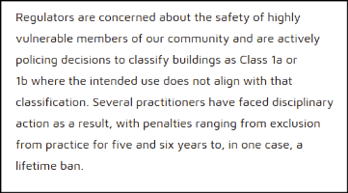
This is a common sentiment in the industry. For example a manager of a Victorian company that installed fire protection sprinklers confirmed that, at one industry gathering that he attended, unsubstantiated statements of this kind was being presented as fact along with Bruce Bromley's presentation arguing that everyone with a disability should have sprinklers in their home.
The 2023 ABCB advice published online addressing both the SDA legislation and the NCC definitions states:
"Question: Would Class 1b be required instead of Class 1a in a house if occupants were 'unrelated'
Response: Occupants of a Class 1a can be unrelated persons (not from the same family). The NCC does not specifically mention or discriminate between the relationship of people living in a Class 1a building. "
and
"Question: What is the building classification to use for the residents (SDA participants who all have a disability, some physical and some cognitive)?
Response: Building Classification is based on occupant profile
- If the occupants are 'People with disability' then the classification is Class 3. Based on level of care it can be Class 3 Residential care.
- If the dwelling is only for 1 person with a disability, then it can be Class 1a i.e., a person with a disability living with their family members. "
This was subsequently taken down, possibly in part due to pressure from the HIA revealed here "HIA with SDA Alliance and the Home Fire Sprinkler Coalition developed a proposal in 2023 for a new building classification. Submitted to the ABCB in 2023 for the technical Federation by regulators".
The hypocrisy is the HIA lobbying housing ministers in 2023 claiming that addition of accessible housing requirements to mainstream NCC Class 1 housing would impose unreasonable costs and regulatory requirements, while at the same time proposing to add millions of dollars to the cost of SDA by adding more mandatory requirements and a unique NCC Classification.
The impact on NDIS participants is a reduced supply of widely available accessible homes.

Who’s in charge of decision-making?
After 10 years of operation there should be an established decision-making process with responsibilities clearly defined.
Despite claims about market stewardship and being responsible for all aspects of SDA, NDIA Home and Living branch don’t actually have the skills and experience to design a home for someone with a severe disability.
It’s now 2026 and the NDIS website states.
“The NDIA doesn’t provide specific technical advice.
SDA assessors should interpret the Design Standard to the best of their professional ability.
If the Design Standard can be interpreted in different ways, SDA assessors should interpret the information that will lead to the best outcome for the participant and confirm this in writing with the NDIA.”
Bypassing state and territory legislation, including consumer protections and technical guidance on building matters in 2019, NDIA still hasn’t put in place a process to deal with technical queries from the public or safety issues resulting from someone with a severe disability living in SDA.
In the most recent chapter in the Robodebt saga the NCAC report disagreed with the Royal Commission, and this is important when assessing governance and accountability in the NDIA.
Apparently, Katherine Campbell and Scott Morrison were not found to have engaged in corrupt conduct because they weren’t familiar with the technical details of implementation of Robodebt. According to the NCAC.
This focus on the question of responsibility within the NDIA Home and Living Bright for SDA decisions also the use by consultants in external organisations regarding key NDIS development work, including the 2019 SDA update (LHA), 2022-23 Pricing review (EY), and the most recent KPMG review of the SDA Design Standard
An example is included later in this submission regarding backup power.
In practical terms, there is a long list of organisations who have been responsible for SDA interpretations, application, and imposing operational requirements with cost implications including:
- NDIA
- NDIS Qualities and Safeguards Commission
- Access consultants in charge a “clarifications”
- Summer Foundation/ Summer Housing/ Housing Hub
- SDA Alliance, and
- state government planning Minister’s e.g. SA AN 01/24

Failure to adopt NCC 2022 Liveable Housing requirements
Housing goals of Australia’s Disability Strategy 2021-2031 should be championed, not left out of mainstream housing requirements, to promote cheap and widespread disability housing;
“Accessible and well-designed housing supports independence and social and economic participation.
Increasing the availability of accessible housing provides choices on where to live an, who to live with, and enables people with disability to visit, socialise and connect with neighbours, family, and friends. Improved take up of universal design principles will support people regardless of age or disability to live in their home through all stages of their lives”
While there have been a few wins such as the DDA, LHA and adoption of NCC 2022 liveable housing requirements, widespread availability of a diverse range of universal design and accessible homes in mainstream housing is at best problematical. Because that’s where innovation and cost savings, and both tangible and intangible benefits to a range of the population in the decades forward, become achievable.
SDA has an enormous cost overhead due to meeting, not the needs of the severely disabled, but the fees and charges of a range of consultant and SDA experts to address complex and unnecessary requirements.
Recommendation - Adopt existing standards enquiry. Cheaper and quicker to use existing standards such as ABCB liveable housing. Wider issues including NDIS failing to mention wiring rules (even if it is a little out of date) and International strategies adoption the internationally recognised 6601 series of standards and relevance to backup power supply design considerations.

Backup power and Renewable energy
This submission uses Clause 22.1 Backup Power Solutions to illustrate a series of problems associated with the current SDA Design Standard and project management implementation.

Renewable energy
A review by the Green Building Council of Australia Taskforce for Climate Related Financial Disclosures in 2017:
“… recommended that Boards of Directors review and analyse the potential for both physical risk and transition risk. Amongst the many recommendations was the consideration of an asset becoming a stranded asset due to its use of fossil fuels, its increased costs due to the use of costlier fuel sources and changing consumer habits and preferences for zero carbon. Business leaders also have a financial responsibility to deliver assets that are affordable and represent value for money over the long-term. This includes being future-proofed for a changing climate and the potential future costs associated with carbon emissions.
NDIA has failed to do so.
Clearly, this has a significant effect on NDIS residents who have to pay the utility bills as well as put in place contingencies in the event of grid outages.
Since 1 July 2025, the Commonwealth and some State and Territory governments are offering rebates to encourage use of solar batteries.
“[Solar Batteries] can offer both financial and nonfinancial benefits. For example:
- saving money by reducing the amount of energy that needs to be purchased at times when energy is not being generated onsite
- less dependence on grid energy and more control over energy use
- providing back-up power when grid blackouts occur (if set up to do so)
- better environmental outcomes for the overall energy system (for example, by reducing the amount of energy purchased from the grid that may come from non-renewable sources).”
More than 30% of Australian households now have rooftop solar PV.
Using solar panels and “solar” batteries for power backup as well as to save money on energy bills, is well-established in mainstream housing - and capable of more than just keeping the lights on.
For example, in 2019 the federal Social Services Minister Paul Fletcher endorsed a project where,:
“Disability housing service, in partnership with Natural Solar, will install a solar panel system and battery to store energy, into homes in a Specialist Disability Accommodation (SDA) development in South Australia.”
All of which is unavailable to NDIS SDA residents because of the failure of the NDIA to prioritise the interests of SDA residents over contractor business interests.

Backup power
Backup power supply requirements in clause 22.1 is manifestly inadequate. There are a range of technical issues not considered, as well as a misleading reference to “life-support equipment”.
Missing from the SDA Design Standard is any reference to AS/NZS 3000:2018 Electrical installations. This is a mandatory requirement called up in State legislation.
IEC standard AS IEC 6060.1.11: 2017: (Full title: Medical electrical equipment, Part 1.11: General requirements for basic safety and essential performance - Collateral Standard: Requirements for medical electrical equipment and medical electrical systems used in the home healthcare environment” applies.
Instead the NDIA endorses recommendations that:
“Solar Storage batteries are not suitable and must not be used as emergency power”
and
“Emergency power solutions. Generally achieved by UPS (Uninterrupted Power Supply. Can also be achieved by generators as long as there is no delay in switching on when there is a power failure”

Backup changeover times
To illustrate the failure of the NDIA to address complex technical issues, just consider the apparently simple question of acceptable backup power change over time. This needs to be carefully considered in order to avoid overly expensive or complex solutions. Demands for “no delay” and “zero change over time” under all circumstances can be rejected as unnecessary.
As a guide, Joint Technical Committee HD/25 responsible for Australian/New Zealand standard for emergency Power supplies in hospitals:
“... was especially requested to review closely what equipment necessitated ‘no break’ supply. In this regard, investigations and comments from hospital staff revealed that very few circuits genuinely necessitate instantaneous re-energization through ‘no break’ systems. As a result, most ‘essential’ circuits within hospitals have been allocated ‘vital’ (30 s) or ‘delayed vital’ (2 min) classifications by this Standard. These classifications provide for the use of more economical and practicable emergency power plant.”
Note that the applicability is defined as:
“those [hospital] medical treatment areas or functions of which regular usage necessitates restoration of lighting and power considered necessary to the continuing safe care of patients. This identification provides a basis for hospital administrators and designers to evaluate the need and type of emergency power and lighting to be provided in a patient-care area.
AS/NZS 3009:1998 recommended change over time for life-support equipment of 20 ms can be considered virtually instantaneous for all practical purposes when used with equipment certified to ISO AS 6060.1.1; which would be the case for SDA.

Unqualified self-appointed experts
The NDIA Home and Living branch has endorsed a practice of endorsing external consultants acting outside their area of competence and failing to provide advice in a professional manner. For example, a freedom of information (FOI) request was lodged to ascertain why access consultants were providing inappropriate and misleading advice regarding backup power supplies.
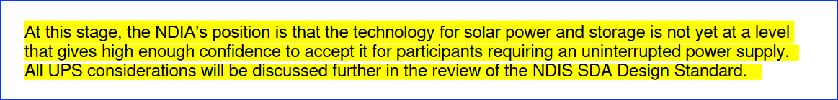
Figure 5 - Bruce Bromley statement of NDIS “position”
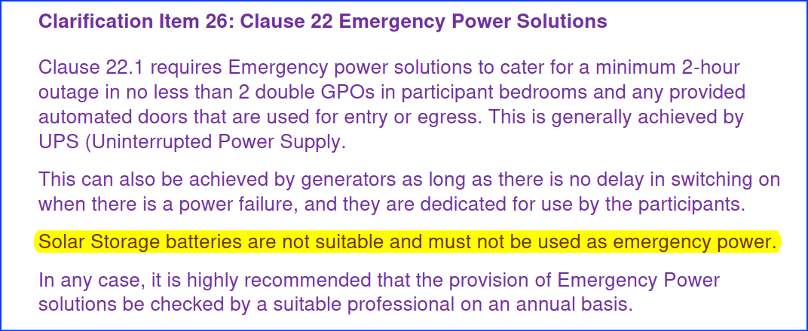
Figure 6 - Clause 22 emergency Power solutions "clarification"
An FOI request was lodged with the NDIA to address statements made in Figure 5 and Figure 6 to:
“provide all documentation relating to this policy decision including written verification of the policy, when it was adopted, who approved the decision, the reason for the adoption and all supporting documentation”
The requested information was not provided by the NDIA because, in part, the 2 individuals concerned, Bruce Bromley (SDA Consulting) and Isaac Prakash (UPS Solutions), claimed that:
“the advice was provided on an informal, ad hoc basis, they did not receive any remuneration for the provision of the advice, and they were not advised what, if any use, the agency would put the advice.”
The Australian Information Commissioner agreed that the NDIA response was inadequate , but a second FOI review by the NDIA failed to produce any further information.
This example highlights lack of accountability and transparency regarding SDA Design Standard technical aspects, along with lack of ethical conduct by access consultants acting outside their area of competence.
In this case, the result is substantial numbers of SDA being built without solar panels and solar batteries, along with expensive and inappropriate Uninterruptible Power Supplies (UPS) and fossil fuel power generators with resulting cost of living and backup power impacts.
To be clear, when correctly in designed and installed by an accredited solar installer, there is nothing wrong with using solar panels and solar batteries for backup power in an SDA registered homes.

Conclusions
The SDA system results in an overly complex and expensive taxpayer funded disability model for a small group of severely disabled.
A suitable plan is required to address the thousands of vacant properties to assist NDIS participants eligible for SDA, but cannot find a suitable property to live in.
More respect for the views, needs, wants and requirements of the people who will be living in SDA is required. Codesign is about ensuring that the SDA design includes both current and prospective residents and is firmly grounded in lived experience. Advocacy services and peak bodies for the various disabilities, and most importantly codesign, is about shared leadership - involvement in design process, advisory group and decision-making.
SDA is supposed to be about people's homes, not mini institutions for residents with a range of disabilities.
We should be celebrating a diversity of innovative disability housing solution along with a variety of NCC classifications – including SDA registered NCC Class 1a family homes owned by their occupants.
The most significant change that needs to be made is to the regulatory environment.
The SDA Design Standard needs to be independently reviewed and managed by a professional organisation such as the ABCB.
The degree of oversight displayed by the NDIA in allowing the situation to develop fails to meet minimum standards of Commonwealth public service accountability and transparency, and this should also be reviewed.
"As the world reassesses its reliance on so-called neoliberal economics, and particularly its faith in market forces, it is important to recognise that the effectiveness of those forces depends on their surrounding regulatory frameworks."

Developing NDIS Housing for People with Complex Support Needs - Position Statement October 2016 Summer Foundation, page 1
"NDIS Specialist disability accommodation Pathway to a mature market PwC & Summer Foundation” August 2017 2017_Winkler_NDIS-Specialty-Disability-Accommodation-Pathway-to-a-mature-market.pdf
"Specialist Disability Accommodation Pricing and Payments Framework Review", Final Report, 3 December 2018, KPMG
Beer, A., Flanagan, K., Verdouw, J., Lowies, B., Hemphill, L. and Zappia, G. (2019) Understanding Specialist Disability Accommodation funding, AHURI Final Report 310 page 43
courtesy of Joseph Canal and
https://dataresearch.ndis.gov.au/reports-and-analyses/specialist-disability-accommodation-sda-data
ibid
Joseph Connellan, LinkedIn post available here
Commonwealth Contract-Goods and Services Reference M000000541, November 2018 , signed by Alexandra Waldron (National policy manager for MBA) in her role as chair of Liveable Housing Australia, FOI document " FOI 22.23 - 0348 - Document - Disclosure Log 1_Part7.pdf"
SDA Design Standard Annual report 2020 page 4, filename: FOI 22.23 - 0348 - Document - Disclosure Log 1_Part8.pdf Since Federation in 1901, state and territory have been managing the building process including registration and certification of building professionals and tradies.. For example PlanSA Accredited Professionals Scheme https://plan.sa.gov.au/our_planning_system/schemes/accredited_professionals_scheme.
NDIS Specialist Disability Accommodation Pricing Review 2022-23 Demand Projections, June 2023 retrieved from https://www.ndis.gov.au/providers/housing-and-living-supports-and-services/specialist-disability-accommodation/sda-pricindg-and-payments/sda-pricing-review 19 October 2025
SDA Design Standard Annual report 2020 page 8, filename: FOI 22.23 - 0348 - Document - Disclosure Log 1_Part8.pdf
Wiesel, I., Laragy, C., Gendera, S., Fisher, K.R., Jenkinson, S., Hill, T., Finch, K., Shaw, W. and Bridge, C. (2015) Moving to my home: housing aspirations, transitions and outcomes of people with disability, AHURI Final Report No.246. Melbourne: AHURI. Available from: http://www.ahuri.edu.au/publications/projects/p71040
Australia's Disability Strategy 2021-2031 - 2024 update: Building a more inclusive Australia, 2024, page 17
https://www.synergisfund.com.au/fund retrieved 23 April 2026
" $12 billion disability housing sector needs investors" published by the Property Council of Australia online dated 07 2020 https://www.propertycouncil.com.au/property-australia/12-billion-disability-housing-sector-needs-investors retrieved 23 April 2026
" NDIS property is no quick buck investment but disability housing demand is growing" published by Property Investor, dated 26 March 2024 https://www.apimagazine.com.au/news/article/ndis-property-is-no-quick-buck-investment-but-disability-housing-demand-is-growing retrieved 23 April 2026
ibid
https://ndis.property/statistics/ retrieved 06 April 2026
Coates, L., Kaandorp, G., Harris, J., van Leeuwen, J., Avci, A., Evans, J., George, S., Gissing, A., van den Honert, R. and Haynes, K., 2019, Preventable residential fire fatalities: July 2003 to June 2017, Bushfire and Natural Hazards CRC. Dated August 2019 on page 69.
Sam Bennett, Mia Jessurun, and Hannah Orban, Grattan Institute, Saving the NDIS - How to rebalance disability services to get better results, June 2025 on page 28.
ibid on Pg 28 “the NDIS Act provides for disabled people to voluntarily move to the aged care system once they are 65, but in practice very few people make this choice because the financial incentives are stronger to stay in the NDIS”.
page 10 of the 2025 Australian Building Surveyor magazine headlined "ABCB yet to resolve classification advice with NDIA" available here.
https://www.ndis.gov.au/providers/housing-and-living-supports-and-services/specialist-disability-accommodation/sda-design-standard
"A practical guide to electrification for new building" Joint report prepared by Green Building Council of Australia, Cundall, Clean Energy Finance Council, and NSW Department of Planning and Environment, page 8, Filename: " a-practical-guide-to-electrification.pdf"
https://www.yourhome.gov.au/energy/batteries
https://arena.gov.au/renewable-energy/solar/
Ken Fullerton, How solar + storage can be a game-changer for people with disabilities republished February 19, 2020 and available https://onestepoffthegrid.com.au/how-solar-and-storage-could-be-a-game-changer-for-people-with-disabilities/
https://probonoaustralia.com.au/news/2019/05/solar-batteries-to-light-up-disability-housing/
The Australian Rehabilitation and Assistive Technology Association (ARATA), Submission to Standards Australia regarding proposal P-004717 to revise AS/NZS 3000:2018, Electrical Installations. Available: https://www.arata.org.au/public/33/files/Publications/ARATA%20Response%20Standards%20Australia%20AS3000%20Proposal%20SUBMITTED%20(1).pdf
Australian Rehabilitation and Assistive Technology Association (ARATA) Submission The National Energy Retail Amendment (Improving life support processes) Rule 2025, 04 September 2025
Farah Madden and (Ms) Joe Manton, Accredited SDA Assessor – Update 4 - December 2021 Clarifications re the SDA Design Standard Interpretations, December 2021, Access Institute
AS/NZS 3009:1998 Electrical installations - Emergency power supplies in hospitals
ibid
NDIS Specialist Disability Accommodation (SDA) Assessor Continuous Professional Development February 2023 Questions and Answers. Published by Bruce Bromley using NDIA letterhead.
Farah Madden and (Ms) Joe Manton, Accredited SDA Assessor – Update 4 - December 2021 Clarifications re the SDA Design Standard Interpretations, December 2021, Access Institute.
FOI 23/24-0269 dated 03 April 2024, Freedom of Information request — Notification of Decision, Assistant Director, Freedom of information Complaints Management & FOI Branch, NDIS
ibid
Dr John Hewson, Honorary Professorial Fellow, Crawford School of Public Policy ANU "Bankster's paradise" The Saturday Paper, 15 October 2022 https://www.thesaturdaypaper.com.au/opinion/topic/2022/10/15/banksters-paradise

