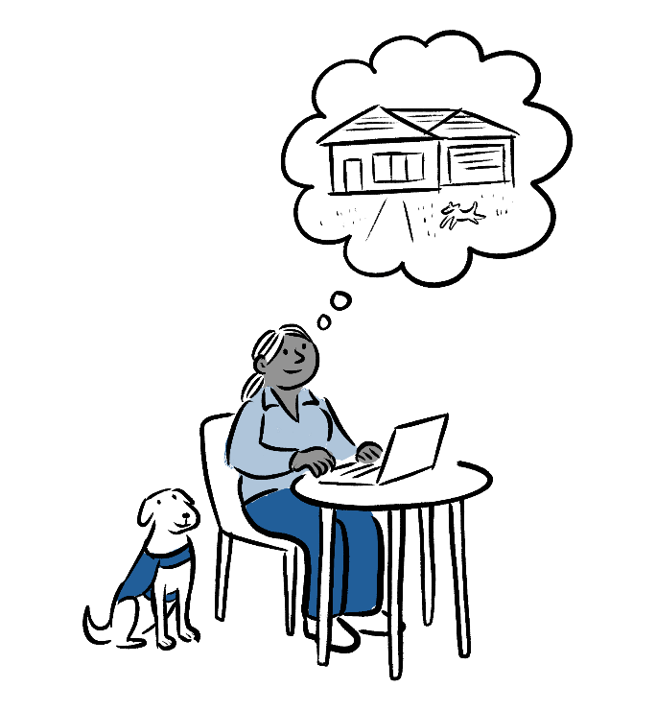

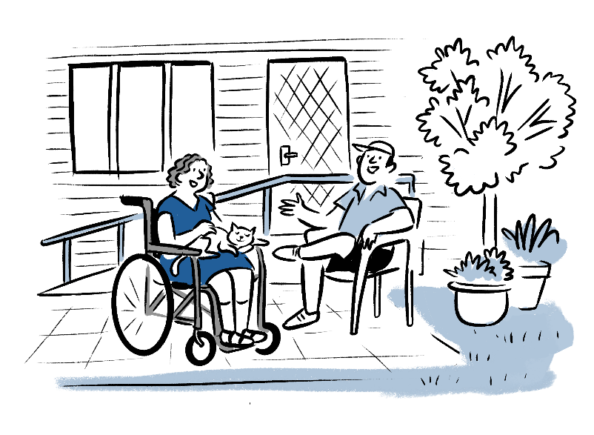
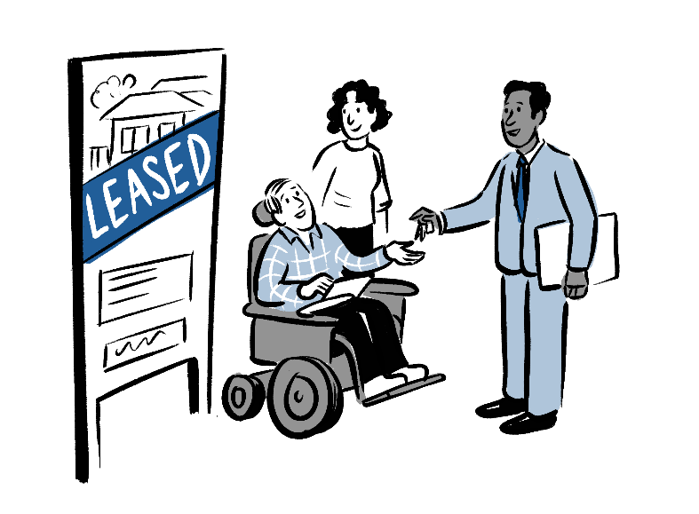

My Housing Matters
  - Housing Matters for People with Disability
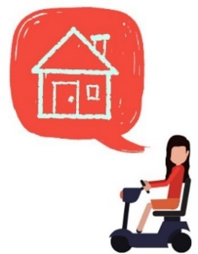
  - A Workbook to help you on your housing journey (Screen Reader version)


About this Workbook

Screen Reader version
This Microsoft Word version of the My Housing Matters workbook is designed to work better with screen readers. The content formatting may change when opened.
If you need a printable version, a standard PDF is available.
See the next page for tips on navigating with a screen reader.

This edition
Rights & Inclusion Australia (R&IA) has published this updated edition of the My Housing Matters workbook under licence from Queenslanders with Disability Network (QDN), as part of the Opening the Door project. Future editions will have links to online resources.
The Opening the Door project is funded through the Australian Government’s ‘Individual Capacity Building’ grant program, overseen by the Department of Social Services. The project is being delivered in partnership with National Shelter, the state & territory members of National Shelter, and Enliven Community.
QDN developed the original My Housing Matters workbook in 2018 as a user-friendly resource to support people with disability to explore their housing options.
QDN would like to acknowledge the advisory group, QDN Housing Champions, and staff involved in the development of the workshop and the original workbook.
If you would like to learn more about QDN check their website https://qdn.org.au/, or phone them on 1300 363 783.

Accessibility issues or other queries
This workbook was made to meet your needs. If you need support to understand what is in the workbook you can email us at projectofficer@riaustralia.org.

Copyright
Copyright in this workbook remains vested in QDN. R&IA has published this version under licence from QDN, for use by individuals. QDN does not grant a Creative Commons licence to other parties for the use of any content in this Workbook.
The copyright for the illustrations in this workbook is held by Jeffrey Phillips (Jeff the Peff). They are used by R&IA and QDN under licence.

Disclaimer
The information contained in this workbook is accurate as of the date of publication but is subject to change based on developments and updates within the housing and disability sector.

Tips for navigating with a screen reader
These tips are mainly for JAWS, but most functions are similar in other screen readers. However, some features may work differently.
For example, in JAWS, you usually activate Quick Keys by pressing the JAWS key + letter Z.
In other screen readers, this may be done using the Screen Reader key + Space and might have a different name.

Navigation tips
- To quickly navigate to elements such as headings, links, etc. in this Word document, activate Quick Keys by pressing the JAWS key + letter Z. JAWS should say, ‘Quick keys on’. Then, press H to move to the next heading or Shift + H to move to the previous heading.
- If you are just reading the text, you do not need to turn Quick Keys off.
However, if you are editing or interacting with the document, press JAWS key + Z to turn Quick Keys off.
- To move to the next or previous page, or to jump to a specific page, press F5 + Tab until you reach your desired option.
The shortcut keys for moving forward or back a page are CTRL + Page Up/ Page Down.
- To learn the current page that you are on, press the JAWS + Page Up.

Interaction tips
- Navigate to a question: press the Up or Down arrow key, Ctrl + Up/Down arrow, to move to the question you want to answer.
- Move between questions: Use the Up/Down arrow or Ctrl + Up/Down arrow to navigate to the next or previous question.
- Checkboxes
- Locate checkboxes: press Ctrl + Left/Right arrow to find the checkbox for your chosen option. Your screen reader will announce whether a checkbox is checked or unchecked as you scroll through.
- Select or deselect a checkbox: press the Spacebar to check or uncheck the box. The screen reader will confirm the selection.
- To confirm your response is registered:
  - If using a laptop, press JAWS key + I.
  - If using a desktop keyboard, press JAWS key + Up arrow.
If using a numpad on the keyboard, ensure Num Lock is off (usually the top-left key on the numpad).
- Return to the question: After selecting a Yes/No option, press Home to move to the beginning of the line where the question is.
- Continue navigating: Press Esc or an arrow key to keep reading and interacting with the document.
- Text Responses
- Entering text responses: When there is an edit field to write a response, the screen reader will say something like ‘Who helped you? Rich text content control write response to “Who helped you?”’.
When you hear a question and instruction such as in the example above, press the End key to move to the end of the line. Then press Enter to write your response.
- Confirm your response is registered:
  - If using a laptop, press JAWS key + I.
  - If using a desktop keyboard, press JAWS key + Up arrow.
If using a numpad on the keyboard, ensure Num Lock is off (usually the top-left key on the numpad).
- Return to the question: After entering your text response, press Home to move to the beginning of the line where the question is.
- Continue navigating: Press Esc or an arrow key to keep reading and interacting with the document.

List of topics
Below is a list of the main topics in this workbook, along with their page numbers.
My Housing Matters 6
The Right Home for Me 8
Types of Housing 10
My Housing Options 12
Assessing My Housing Needs 21
My Home Right Now 23
NDIS Funding for Housing 24
Planning My Ideal Home 26
Next Steps in Finding the Right Home for Me 30

My Housing Matters

Finding the Right Home
Everyone needs a home that is secure, affordable, accessible, and well-located. For people with disability, having a home that meets these needs is just as important.
The My Housing Matters workbook helps people with disability to understand their rights and empower them to have choice and control over their housing options.
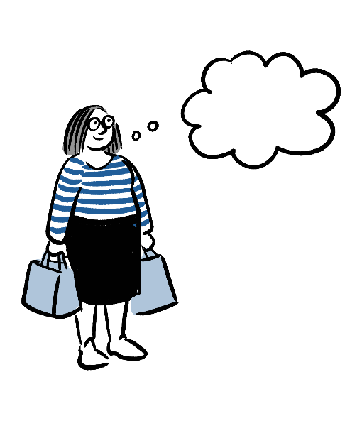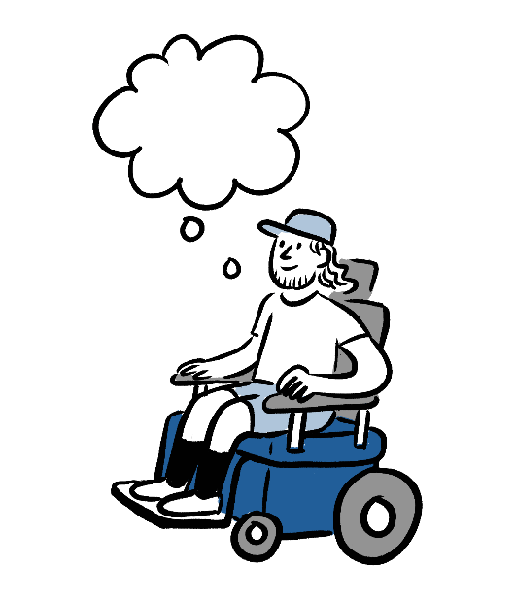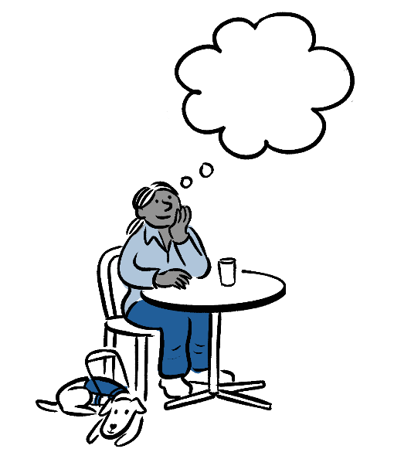
Here’s how this workbook will help you on your housing journey:

Picture the Home you want
- What It Is: Think about what type of home would be best for you now and in the future.
- Why It Matters: Knowing what you want helps you make the best decisions for your living situation.
For example:
- Jane wants to live by herself. She feels safer in a small home, and she like to have a quiet environment. Jane needs to be close to public transport so she can catch a bus to work or to see her friends.
- John feels lonely when he lives by himself. He would like to live in a house with other people. John has support workers, and he loves gardening and his cat Misty. John would like a home with a small garden that’s pet friendly.

Learn about your options
- What It Is: Find out about different housing choices and their advantages and disadvantages.
- Why It Matters: Understanding what each option offers helps you choose what works best for you.

Get ready for the next steps
- What It Is: Learn the steps to finding a home that works best for you.
- Why It Matters: Being confident and prepared helps you move forward in finding the right home.

Use this guide to explore your options and take control of finding a home that fits your needs and makes you happy.

The Right Home for Me

A place to call Home
For most people, having a place they can call home is important. They can often choose where they want to live. But many people with disability face challenges finding a home that meets their needs. Some might live with their parents into adulthood, stay in group homes or residential aged care, or struggle to find a stable place to live.

Your Rights
When thinking about your housing needs, it is helpful to know your rights and the responsibilities of others to make sure your rights are supported.
These rights help make sure that you can find suitable housing and get the support you need. It is the responsibility of others to make sure that laws protecting the housing rights of people with disability are properly followed.
Your rights to housing are:

Disability Discrimination Act 1992 (DDA)
- People have the right to access housing without being treated unfairly because of their disability.
- They can request changes to their housing to meet their specific needs.
This means Service Providers must make their housing services accessible and not discriminate against people with disability. Landlords and Real Estate Agents need to make reasonable changes to help with disability renting a home.

National Disability Insurance Scheme Act 2013 (NDIS Act)
- People can get funding for necessary housing support.
- They have the right to choose housing that fits their individual needs.
This means National Disability Scheme (NDIS) Providers must provide services that respect the choices and rights of people with disability, including housing options. State and Territory government agencies need to give information and support about housing rights and options under the NDIS.

State and Territory Laws
- People have the right to be free from discrimination in housing according to local laws (like the Equal Opportunity Act).
- They should have access to housing that meets accessibility standards set by local building rules.
This means Governments are responsible for making sure all the rules to make housing accessible are followed. Housing Authorities must create policies to make sure people with disability have fair access to housing.

Australian Human Rights Commission Act 1986
- People can seek help if they face discrimination in housing or related services.
This means employers and organisations must have anti-discrimination policies to follow human rights laws.

The My Housing Matters workbook focuses on four key values to make sure people with disability have a home they can truly call their own. Values are our beliefs that shape how we act and make decisions.
- Rights: You have the same rights and responsibilities with your home as everyone else.
- Choice: You have your own place to call home.
- Inclusion: You can join in social activities and be a part of the community like anyone else.
- Control: Your housing is managed separately from the support you get.
We want everyone to understand what people with disability need to live and engage fully in their chosen community, including the people and places that support their preferences and needs.

Types of Housing
Everyone needs a home that suits their needs, and there are many types of housing in Australia. If you have a disability, finding the right place is important. Options range from standalone houses and apartments to housing with support. Here’s a simple guide to help you understand your housing choices.

House
A house is a home on its own block of land, usually with a yard and no shared walls with other properties. A semi-detached house is where two homes are next to each other, separated by a shared wall.

Duplex
A building divided into two separate homes, each with its own entrance, often sharing a wall.

Villa
A single-storey, often semi-detached home in a small complex, usually with shared gardens or driveways, offering more privacy than an apartment.

Townhouses
A multi-storey home, often part of a row of connected properties, with shared walls but individual entrances and small private yards.
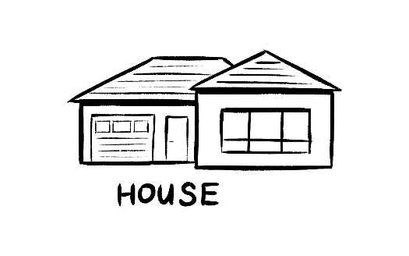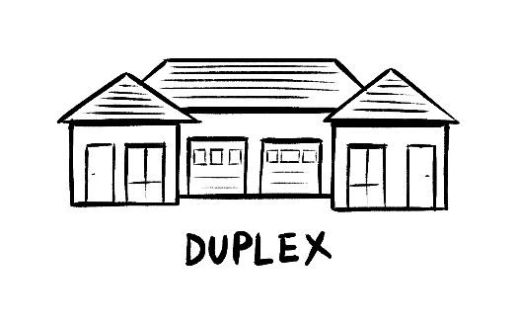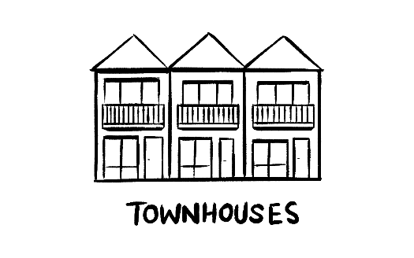

Apartments (Units/Flats)
A self-contained home within a multi-level building, typically sharing common areas like hallways and entrances with other residents.
A studio apartment is a smaller apartment with one open area for living, sleeping, and cooking.
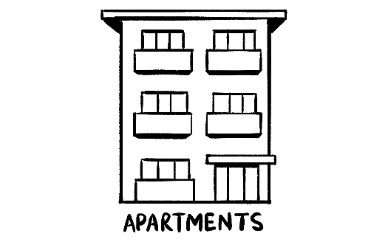

Granny Flats
A small, self-contained living space on the same property as a main house, often used for family members or as a rental.

Group Home
A share home where people who may not know each other live. They often look like a house and the people living there may share supports.

Boarding House (Hostel)
A building where people rent individual rooms and share common areas like bathrooms and kitchens, often for short-term stays.

Caravan/Relocatable Home
A mobile home or trailer, typically located in a caravan park, often used for holidays or as low-cost housing.
Relocatable homes typically provide a more permanent living option than a caravan but with the flexibility to be relocated.

Retirement Village
A community of homes or apartments designed for older adults, offering independent living with some shared amenities or services.

Residential Aged Care Facility
A residential facility that provides accommodation and care for elderly people who need help with daily activities and medical needs.

My Housing Options
There are different types of housing and ways to live, like renting an apartment, which we call ‘housing options’. It’s helpful to choose a place where you can live for a longer time and that suits your needs.
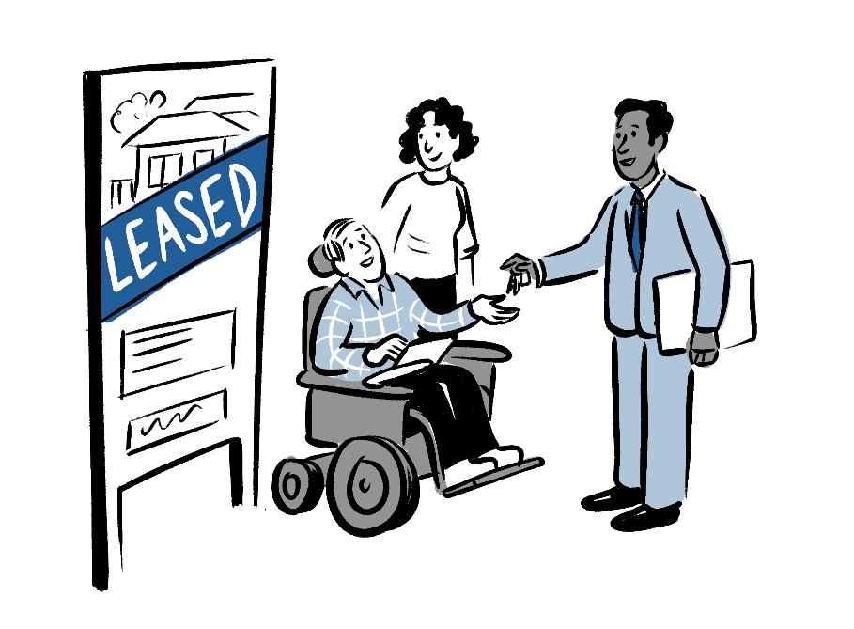

Home Ownership
Home ownership means you own a house and can live in it. As a homeowner you are responsible for taking care of it and paying for repairs.

What you need
- Age: You need to be of legal age.
- Proof of Income: A reliable job and information from your bank to show you can afford your mortgage payments.
- Deposit: Money saved up to pay part of the house price. You will need to pay part of the house price during the process of buying a home.

Process
- Save Money: Save for the deposit and get a home loan approval from a bank.
- Look for a Home: Find a house you like. You can use a real estate agent to help you.
- Offer money: Offer to buy the house and agree on a price with the seller.
- Buy the house: Check the home, finalise your home loan with the bank, and sign the papers to complete the purchase.

Good points
✓ Control: You can make changes and adapt your home the way you like.
✓ Choice: You can pick a house that fits your needs.
✓ Long-Term Home: Owning a home gives you a place to live for as long as you want.
✓ Home Price: Homes often go up in price, so you can make money by selling your home in the future.

Things to think about
? Expensive: It’s expensive to buy a house, especially with saving for a home loan.
? Paying Bills: You’ll have regular costs like maintenance, property taxes, and insurance.
? Price Changes: Home loan prices can go up or down, which means your home loan payments will change.

Private Rentals
Private rentals are homes or apartments owned by other people or companies. These people or companies are known as landlords. Renting privately means you’re paying a person or company to live in the house or apartment for a period.

What you need
- Age: You usually need to be 18 or older.
- Proof of Income: Show you have a reliable job and can afford to pay the rent.
- Bank information: Have a good record of paying rent on time.
- References: People you have rented a home from before, saying you are reliable, pay your rent on time and looked after their property well.
- Deposit and Bond: Money that you need to pay the landlord at the start of a rental period.

Process
- Find a Home: Look for places that you would like to rent that suit you. You can use a real estate agent to help you.
- Apply to Rent a Home: Fill out a rental application and show you can afford rent.
- Pay a Deposit and Bond: Pay rent in advance along with a bond before moving in.
- Sign the Lease and Move In: Sign the rental agreement and get the keys to your new place.

Good points
✓ Choice: You can choose a place that suits your preferences.
✓ Flexibility: You can move on and find another place to live without needing to sell a home first.
✓ Availability: Rental homes may be easier to find than finding a home to buy.
✓ Rent Assistance: You might be able to get Rent Assistance if you're receiving Centrelink payments.
✓ Share with Flatmates: You have the option to find flatmates to share the rent with you.

Things to think about
? Expensive: Renting a private place might cost a lot of money.
? Accessible Homes: It can be difficult to find homes with accessibility features.
? Less Security: You might not be able to rent long-term if you want to.
? Limits on Changes: You can't always change the home to fit your needs.

Shared Accommodation
Renting a room in a house or apartment and sharing common spaces like the living room, kitchen and bathroom with others.

What you need
- Age: You usually need to be 18 or older.
- Income: You need to be able to pay your portion of the rent regularly.
- Rental History: Proof you pay your rent on time.
- References: People you have rented from before, saying you are reliable, pay your rent on time and looked after their property well.
- Personal Fit: Landlords may want to make sure you’ll get along with housemates.

Process
- Search for Rooms/ Housemates Wanted: Look online on social media, for available rooms. You can ask a support person to help you.
- Contact the Advertiser: call or send a message to the person renting the room to ask questions.
- View the Property: Visit the place and meet the other housemates if possible.
- Submit Application: If you like it, fill out an application and give documents like proof you can afford to pay rent and references.
- Sign a Lease: Once accepted, sign a rental agreement that sets out the rules of living in the chosen shared accommodation.

Good points
✓ Cheaper: Renting a room is usually cheaper than renting a whole place.
✓ Social Opportunities: You can make friends and feel part of a community.
✓ Shared Costs: Bills and food shopping can be split with housemates, saving money.
✓ Flexible Leasing: Many places offer short-term leases, which is good for temporary stays.
✓ Furnished Options: Some rooms come furnished, so you don’t need to buy furniture.

Things to think about
? Possibly Less Privacy: Sharing common spaces like kitchen, bathroom and living room means you may have less alone time.
? Not Getting Along: Differences in personalities may mean you don’t always get along with your housemates which could be stressful.
? Shared Responsibilities: Cleaning and maintaining common areas often means teamwork, which can be tricky.

Social Housing
Social housing is a term for public and community housing that is rented at lower prices to people with low incomes or specific needs. Community housing providers may also offer extra help and support services.

What you need
- Have a Low Income: The money you get from work and government supports must be below a certain level set by the government.
- Be a Resident: Be an Australian citizen, permanent resident, or hold a specific visa.
- Show Need: Prove you need affordable housing.
- Live Locally: Sometimes, you need to live in the area where you're applying for housing.

Process
- Check if You Qualify: Make sure you meet the housing provider’s eligibility criteria.
- Prepare Documents: Gather important papers like ID and proof of income.
- Apply: Fill out and send your application to a local housing agency.
- Wait for Review: The agency will check your application and documents.
- Get an Offer: If approved, you’ll be offered a property once one becomes available. You can then sign a lease and move in.

Good points
✓ Affordable Rent: The rent is set to be affordable for people with low incomes.
✓ Stable Housing: You get a secure, long-term place to live.
✓ Accessible Homes: Some homes are designed for people with disability.
✓ Extra Help: A housing agency/ provider may offer home adjustments and support services to fit your needs.

Things to think about
? Long Wait: It may take a long time to get a place, because of other people on the wait list.
? Less Choice: You may not have many options about where you live.
? Location: Social housing is not always located in areas close to public transport and shops.

Specialist Disability Accommodation (SDA)
Some NDIS participants may be eligible for Specialist Disability Accommodation (SDA). This is housing specifically designed or modified for those with an ‘extreme functional impairment’ or ‘very high support needs’. SDA is usually rented to participants by an SDA provider. However, it is also possible for people to build their own SDA.

What you need
- Eligibility: You must be an NDIS participant with an extreme functional impairment or very high support needs.
- Evidence: You need to show that you need SDA housing, because it meets your needs more than non-specialised housing does.
- Assessment: The NDIS will assess whether you are eligible for SDA based on your disability and housing needs.

Process
- Gather Evidence: Get reports from health professionals and support workers showing your eligibility and why you need SDA.
- Update Your NDIS Plan: Work with an NDIS planner or support coordinator to make an application for SDA funding.
- Assessment: NDIS will review your application and decide if you are eligible for SDA.
- Find an SDA Provider: If approved, you can start looking for a suitable SDA home.
- Moving in: Once you choose a place, sign a tenancy agreement. Then you can move in and start paying rent.

Good points
✓ Built for Disability: SDA housing is designed for people with disability, making everyday living easier.
✓ Affordability: The NDIS covers the cost of the housing itself – the rent you need to pay is capped. This makes it affordable for eligible people.
✓ Access to Support Services: Many SDA homes offer on-site or nearby support, improving safety and convenience.
✓ Stable Housing: You get a secure, long-term place to live.

Things to think about
? Availability: Limited availability of suitable SDA, particularly in regional and rural areas.
? Location: SDA houses may be in areas that are not close to public transport, shops or your family and friends.
? Lack of Choice and Flexibility: You may have limited say in the design of the home. There may be limited say in choosing housemates.

Affordable Housing
Affordable housing is rented or sold at prices price below the full market price. It is for people who earn less money or who are not able eligible for social housing, and who struggle to afford private rentals. Some community housing providers offer both affordable rental and social housing.

What you need
- Income Limits: You need to show that your income is below a certain level, which changes by state/territory and how many people you live with.
- Residency Status: Most programs require you to be an Australian citizen or permanent resident.
- Housing Need: You must prove that you need affordable housing - like if you’re homeless, there’s too many people in your current home, or struggling to pay rent.
- What you own: Some programs may look at your savings or property and set limits on their value.
- Age and Family Status: Certain programs may give priority to families, single parents, older people, or people with disability.

Application process
- Find out more: Look into local housing providers and programs, as they can be different in each state/territory.
- Get Your Documentation Ready: You’ll need to show proof of income (like pay slips), residency status, and perhaps your disability.
- Submit Application: You can usually apply online or in person. This often involves filling out a form.
- Assessment: After you apply, housing providers will look at your application. This might include interviews or asking for more documents.
- Waitlist: Many programs have long waitlists because of lots of people needing affordable housing. You might have to wait some time before getting an offer.
- Offer of Housing: If successful, you’ll get an offer for housing. You can choose to accept or decline it.

Good points
✓ Access: Helps people and families find stable homes, easing financial stress and reducing the risk of homelessness.
✓ Cheaper costs: Lowers housing costs, so that there’s more money for other things like food and education.
✓ Builds Communities: Encourages a mix of different people, making a community more inclusive.
✓ Location: Often located close to shops, public transport and other services.

Things to think about
? Limited Availability: There isn’t enough affordable housing, meaning you might have to wait a long time to be offered one.
? Funding: Programs often rely on government money, which can change and affect the availability of affordable housing.

Group Homes
Shared homes where several people with disability live together. They get support from staff who help with daily activities and personal care.

What you need
- Disability Type: Generally, for individuals with high support needs.
- Local Programs: Eligibility may vary based on local state or territory programs.

Process
- Application: Contact your local disability services or housing authorities.
- Assessment: An assessment will be done to understand if a group home would be a good option for you.
- Placement: Depending on your assessment and other factors, you may be offered a space in a group home with supports.

Good points
✓ Supportive Place: Gives a structured, supportive living situation with professional care.
✓ Social Interaction: You can share the group home and activities with other people.
✓ 24/7 Support: Group homes often include day and night care and support.

Things to think about
? Less Privacy: Shared living spaces can have less privacy and personal space.
? General Support: May lack personalised services tailored to your individual needs.
? Location: Group homes may be in an area you may not want to live in.
? Community opportunities: May have less opportunities to join in with community activities.

Programs associated with Housing Options

Housing Support Programs
Housing support programs can help you find and keep suitable housing by giving you money, advice, and/ or extra resources, especially if you have a disability. They make it easier to access different housing options by offering help and funding.
These programs are made to fit your needs. However, the availability and quality of these programs can vary by location, and each state will work differently. It is important to find out more information about housing support programs from your state government.

Home Modifications
Home modifications are changes made to a home to make it safer and more accessible for people with disability or mobility issues. These can include things like smart home systems, ramps, widening doorways, and handrails to help individuals live more independently and comfortably.

Supported Independent Living (SIL)
SIL is a package of support services that some people with disability can access. It aims to help people live as independently as possible.
SIL can be provided to people living in both a shared or individual living situation – from private homes, to SDA homes, to group homes. It does not always come with housing.

Assessing My Housing Needs

Is your current Home right for you?
Now you understand your rights, below are some questions to help you decide if your current home is right for you.
For each question, there are two options: ‘Yes’ or ‘No’.
If you need help navigating the questions, go to ‘Tips for navigating with a screen reader’ on page 3.
Rights: You have the same rights and responsibilities about your home as everyone else.
- Have you thought about where you want to live? yes no
- Have you thought about who you want to live with? yes no
- Has anyone helped you think about this or encouraged you? yes no
Who helped you? Click or tap here to enter text.
- Can you make decisions about your home? For example, can you decide who lives with you and who can visit? yes no
- Do you have someone to help if you have a problem with your home? yes no
Who can help you? Click or tap here to enter text.
- Do you feel safe about yourself and the things that you own? yes no
- Do you have enough privacy? yes no
- If you are renting, do you know your rights as a tenant? yes no
- If not, do you know someone who can help you understand your rights? yes no
Who are they? Click or tap here to enter text.
Choice: You have your own place to call home.
- Do you live in an area and type of home that you want? yes no
- Are you living with the people you want to be with? yes no
- Can you make your home suit your needs and interests? yes no
- Are you able to change where you live if you want to? yes no
- Do you have someone to help you think about moving options? yes no
Who is it? Click or tap here to enter text.
- Do you have different affordable housing choices available? yes no
- Do you have someone to help you find affordable housing? yes no
Who is it? Click or tap here to enter text.

Inclusion: You can join in social activities and be a part of the community like anyone else.
- Is your home close to public transport, the services you need, and other useful places? yes no
- Do you live close to your friends and family, or can they visit you easily? yes no
Control: Your home and your supports may be managed by the same service providers or different service providers.
- Is your home affordable, safe, and right for your needs? yes no
- Can you live with people who are supportive and welcoming of you and your support workers? yes no
- Is your housing managed separately from the support services you receive? yes no

If you answered ‘no’ to many of these questions, your home might not be right for you.
‘Understanding what kind of home you want increases your chance of getting it.’

My Home Right Now

How well does your Home meet your needs?

Things that I like and don’t like
Below are three questions about how well your home meets your needs.
If you need help navigating the questions, go to ‘Tips for navigating with a screen reader’ on page 3.

What do you like about where you live now? What works well for you?
(Provide up to 4 responses below)
- Click or tap here to enter text.
- Click or tap here to enter text.
- Click or tap here to enter text.
- Click or tap here to enter text.

What don’t you like about where you live now? What does not work well for you?
(Provide up to 4 responses below)
- Click or tap here to enter text.
- Click or tap here to enter text.
- Click or tap here to enter text.
- Click or tap here to enter text.

If you could change one thing what would that be?
(Provide your response below – add as much detail as you think is necessary)
Click or tap here to enter text.

NDIS Funding for Housing

The NDIS can help your home work better for you
The NDIS can help you make changes to your home, so it fits your needs better. This could include adding useful modifications or equipment to help you live more comfortably and independently.

Specialist Disability Accommodation (SDA)
- What It Is: Money to help with housing that’s specially designed or adapted for people with high support needs.
- Who It’s For: People who need very high levels of support or special housing modifications.
- What’s Covered: Costs for the special accommodation and related expenses.

Supported Independent Living (SIL)
- What It Is: Money to help with living independently with support from others.
- Who It’s For: People who need help with daily activities but want to live on their own or with housemates.
- What’s Covered: Costs for support workers to assist with things like personal care and household tasks.

Home Modifications
- What It Is: Money to make changes to your home to make it more accessible.
- Who It’s For: People whose homes need changes to meet their needs.
- What’s Covered: Modifications like ramps, accessible bathrooms, and other changes to make your home better for you.

Assistive Technology
- What It Is: Money to buy equipment that helps with daily living tasks.
- Who It’s For: People who need special equipment to help with things like moving around or communicating.
- What’s Covered: Technology like automated doors, mobility aids, and communication devices.

Individualised Living Options (ILO)
- What It Is: Money to help create flexible living arrangements that suit your needs and preferences.
- Who It’s For: People who want more choice and control over where and how they live but need some support.
- What’s Covered: Help with designing a personalised living arrangement, finding suitable housemates or hosts, and support to maintain independence.

Core Supports
- What It Is: Money for everyday needs and activities.
- Who It’s For: All NDIS participants, based on their needs.
- What’s Covered: Personal care, help with daily activities, and other support services.

Capacity Building Supports
- What It Is: Money to help you build skills and become more independent.
- Who It’s For: All NDIS participants, based on their goals and needs.
- What’s Covered: Training and support to improve daily living skills and find suitable housing.

How to use NDIS for your housing needs
You may be able to use your NDIS funding to help you with your housing needs. Here are some simple steps to using NDIS funding for housing:
- Talk with a NDIS planner or local area coordinator about your needs and goals for housing. You have the right to have an advocate with you during your talk with the NDIS.
- Your NDIS plan can include money for the supports and services you need, including housing.
- Use your NDIS plan to get the help you need, including finding or modifying housing and getting support services.
- Your NDIS plan will be checked regularly to make sure it still meets your needs. Changes can be made if needed.
For more help contact the NDIS directly or speak with your NDIS planner. They can provide guidance on what you can get and how to use your plan effectively.

Planning My Ideal Home

What’s important to you in your Home?
To find a home that works best for you, think about what makes it easier to get around and feel comfortable.
Below is a list of home options, each with a single checkbox. If an option is important to you, then check the box. If it isn’t, leave the checkbox empty. If you need help navigating the questions, go to ‘Tips for navigating with a screen reader’ on page 3.

Where would you like to live?
- In the city (A busy place with many people)
- In the suburbs (A quiet area near the city where people live)
- A regional town (A small town near the countryside)
- A remote area (A place that is far away from busy places with very few people)

What housing options suit your needs?
- Specialist Disability Accommodation
- Supported Independent Living
- Group homes
- Community housing
- Private rental with disability modifications
- Residential aged-care facilities
- Assisted living retirement village
- Home and community care services
- NDIS home modifications
- Disability housing support programs

What type of home suits you?
- Home ownership
- Private rental
- Shared accommodation
- Social housing
- Detached House
- Semi-detached house
- Terrace House
- Townhouse
- Apartment (unit/flat)
- Studio apartment
- Granny Flat

What matters most to you for your home’s design?
- Energy Saving (uses less power so saves you money on your bills)
- Easy to Move Around (e.g., accessible bathroom, adjustable counters, wide doors)
- Located on the ground floor
- Smart Technology (e.g., automatic lights, temperature control)
- Low Maintenance (e.g. easy to clean and look after)
- Good Insulation (e.g. keeps the temperature just right, outside noise reduction)
- Safe and Secure
- Lots of Storage
- Modern Appliances (e.g., energy-saving fridge, smart oven, advanced dishwasher)

What would you like in your environment?
- Having a garden
- Close to nature
- Peace and quiet
- Near a vibrant and lively area
- Freedom to play music and make noise
- Close to community and outdoor activities
- Close to shops and services
- Close to public transport

What makes you feel safe in your home?
- Alarms
- People you trust nearby
- Strong locks and security screens on doors and windows
- Well-lit outside areas (e.g. streetlights, outside lights)

Who would you like to live with?
- Living on my own
- Living with family
- Living with friends
- Living with my pets
- Living with new people

If you selected ‘yes’ to living with new people, who would you like to live with?
  - People who share my interests
  - People with disability
  - People with different beliefs
  - Female housemates
  - Male housemates
  - People who do not identify as male or female
  - People with pets

How would you like your supports/carers to help you?
- Living in my home
- In my home support
- Visits at scheduled times
- Regular check-ins
- Support via phone or online

What would you like your Home to look like?
Use the information in this workbook, your answers to questions, and your own lived experience.
On this page you can draw or write what you would like your home to look like and include. For example, a house with a garden in a quiet area, or an apartment in a busy city living with your family. If you wish, you can use a support person to help you.
If you need help navigating here, go to ‘Tips for navigating with a screen reader’ on page 3.
Click or tap here to enter text.

Next Steps in Finding the Right Home for Me
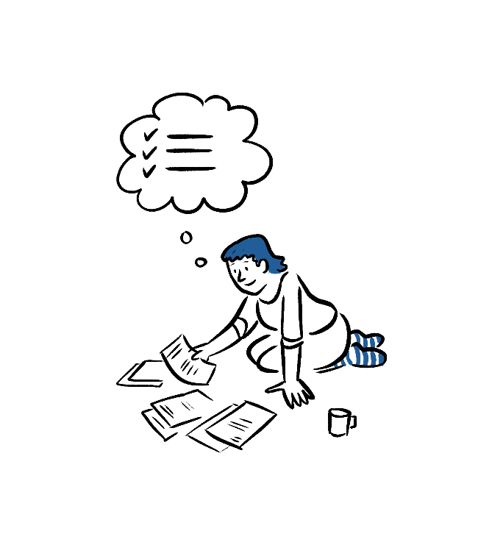
What are my next three steps to move towards an accessible home that’s right for me?
If you wish, you can use a support person to help you plan your next steps.
List your three next steps below. If you need help navigating here, go to ‘Tips for navigating with a screen reader’ on page 3.
- Click or tap here to enter text.
- Click or tap here to enter text.
- Click or tap here to enter text.

